Week 1

Workshop 1
27/07/2026
Ai is taking over coding, the useful skill is your organisation, documentation and understanding of the method and results.

can you please provide a summary of this entire notebook. It should compile to a 10-15 minute read and detail all of the important concepts and ideas shared in this notebook. Include all key definitions and highlight any parts of the notebook you recommend me reading over more thoroughly (i.e. if they are highly important concepts). From your summary I should be able to compile a comprehensive set of notes for personal study.

Week 1 Prework
(being done after the workshop lol)

Artificial intelligence: attempts to get a machine to behave in ways that would appear to be intelligent.
Machine learning: is a subsection of AI and involves building a model from data, where the model accepts a series of inputs and generates an output.

Computer Hardware
Central processing unit: understands and executes instructions that are given in the form of binary units, 0 and 1’s fed by transistors (on/off)
BOOLEAN: True == 1 and False == 0
To express numbers in binary form we need to convert from base 10 (what we know and love) to base 2 form.

8 bits == 1 byte (related to integers)
16 bits == half precision, 32 bits == single precision, 64 bits == double precision (related to floating point)

Hyperthreading: having two sets of queued instructions ready to run on each core. Can achieve 15-30% improvement with CPUs spending less time waiting for instructions and data
Vector Processors: have a vector unit which specifies the number of bits they can operate on simultaneously. (A processor with a 256-bit vector can execute 64-bit (double precision) instructions at once.

CPU’s aren’t getting faster because we have basically maxed out the amount of transistors we can squeeze onto a single CPU. Associated with Mohr’s Law
Parallelism: running multiple less power hungry processors to achieve the same outcome as a larger more draining processor.

How we quantify computer system performance

Quantified by measuring the ‘clock speed’ – number of cycles a processor can perform per second.
FLOPS: Floating Point Operation Per Second, the number of operations a computer can perform. (more useful than just the number of cycles) – it is number of cycles and the number of operations per cycle.

Graphical Processing Unit (GPU): design for rendering 3D graphics which requires performing multitudes of matrix operations.
- Neural networks (the thing that is driving Ai) is built on matrix calculations, thus the boom of GPU’s fed the boom of Ai

Interpreted vs Complied Languages
Complied - hard and brute, old school, no helpful uis or suggestions, just get it right or else.
- Usually written in a plain text file in the intended language before being sent to a compiler which translates it into machine code that is optimised for the hardware on which its compiled. Picky
Interpreted - much more user friendly, modernised and more forgiving.
- Significant difference with complied is that it reads and interprets code line by line, rather than going through the entire code before executing like a compiler does.
- Compiler takes more time but enables the final code to adapt better to the local computer.
- Interpreted code like python can take longer due to having to back track and reorganise during execution of the instructions
- Code is easier to read and understand
- Code is more hardware independent and portable across different computers
- Can however use more memory and be slower to execute.

Data Management and Version Control
Version control and work history are super important

GitHub
Repository: where you store your source code files
Branch: Copy of the code that splits off from the main code
Merge: removes a branch and replaces the parent branch with the one that is being removed
Pull: when you call a version of code from the repository to your local device
Push: when you send the current version you’re working on back to the repository
Commit: when you let the repository know that you have made a significant change
Cloning: take a copy of existing code and files in a repository and then edit it without your changes impacting the original repository.
Gist: mini Git Repository, when using google colab, we can consider it as a static clone of your notebook. Can’t store folders like a full repository. Can’t branch a gist. Only useful to share a single file of code.

Documenting Code and Digital Projects
In-line code: simple and just used to understand what is happening line by line
Documentation Strings (Docstrings): More indepth and informative, used for things like functions and importantly can be called using the help function. Begin and end with “””
- Need to be consistent in style with docstrings, use the google style as its most human readable and writable probably

Charts and Algorithms
Common symbols
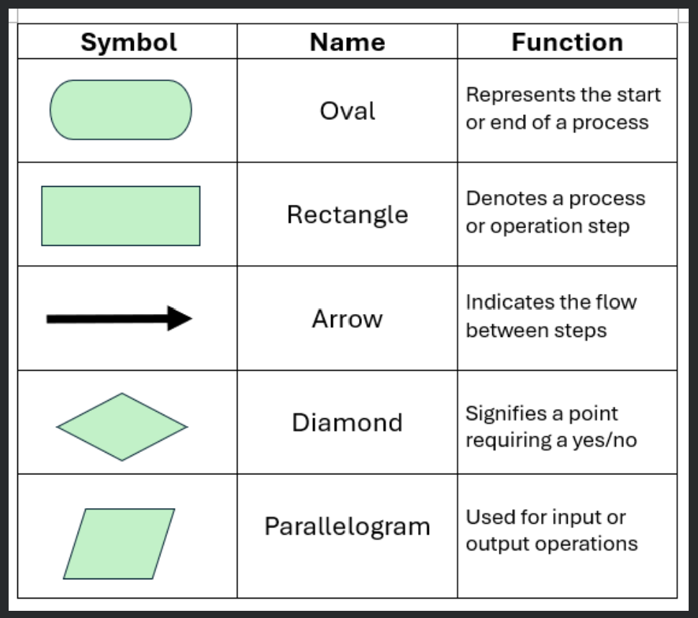

Additional Symbols
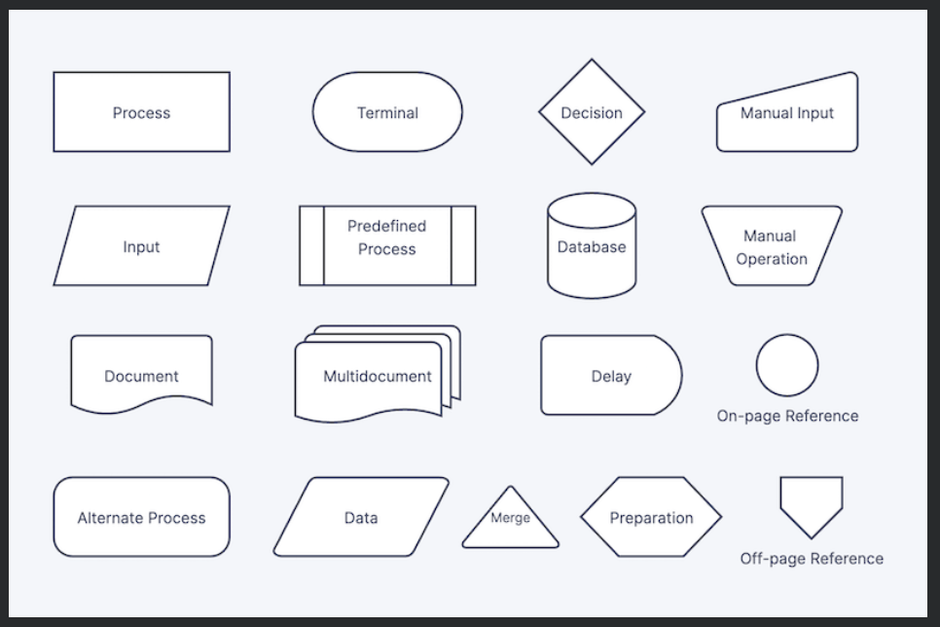

Mermaid Diagrams: text-based, Markdown-inspired scripting language that automatically generates and renders diagrams and charts using JavaScript

“Doc-rot”: where documentation becomes outdated, and subsequently inaccurate, as the code or processes evolve.

Pdoc: a third-party library designed specifically to auto-generate modern, visually appealing API documentation web pages.
Pydoc: a built-in Python module that serves as an offline reference manual and basic documentation generator

Create a python doc with all the necessary documentation, explaining how functions and different components link etc then use pydoc or pdoc to interpret and read it. Pdoc is much more powerful and create sexy pdfs

Responsible use of Ai
Always acknowledge and take accountability
- Note what tool was used and how it was implemented
AI is a powerful tool, but it does not replace human judgement and responsibility

Use AI to point you in the write direction and aid you in completing task, but always look to professional standards, published papers and textbooks - permanent documents that can be cited to back up your assumptions, methods, etc.

Data leaks and privacy, anything you upload onto generative ai is uploaded onto a public domain, watch out buttercup
Attackers can corrupt training datasets, causing models to make incorrect decisions, misclassify data, or create security backdoors.

Testing, Debugging and Validation
Testing: the process of checking that your code works as intended and identifying potential problems
Debugging: the process of finding the root of the problem within the logic or operation of the code and correcting it
Validation: is confirming that what you have developed meets the original requirements and provides the solution that motivated the codes development
Positive Testing: Ensures code delivers expected results for valid input.
Negative Testing: Ensures code handles unexpected, corrupted, or out-of-scope input.
Pytest: A Python library for writing, running, and collating results of functional tests.
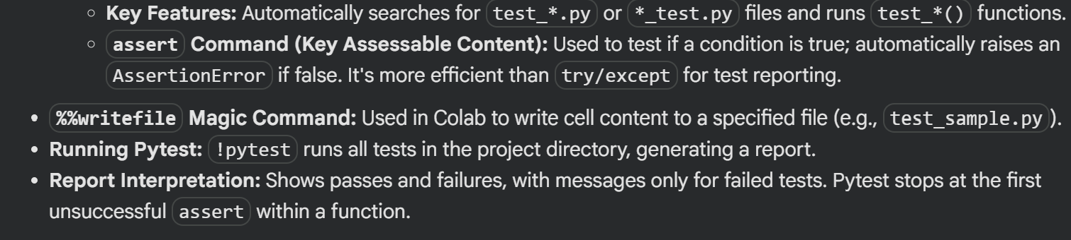
Bug: Software error causing unintended results, erroneous calculations, or unstable behavior.
Security Vulnerability: A specific bug exploitable by malicious actors.
Functional Bugs: Features don't work as intended.
Logical Bugs: Errors in logic or calculations leading to incorrect results.
Syntax Bugs: Errors in code structure (missing semicolons, indentation).
Performance Bugs: Code fails or becomes inefficient for larger problem sizes.
Boundary/Edge Case Bugs: Errors at extreme limits of input values.
Segmentation Fault: An error when a program tries to access memory it's not permitted to (e.g., out-of-range index).

Week 2

Week 2 Prework
Optimisation and Profiling

Why:
- Numerical performance directly impacts cost and feasibility of engineering simulations
- Also related to energy consumption
- Green computing = maximising performance per Watt of electrical power consumed

Topology:
- Memory Hierarchy: CPUs access data from a hierarchy of memory, from fastest (L1 cache) to slowest (main RAM, hard disk). Cache hits are fast, cache misses are slow as data must be fetched from slower memory.
- hwloc and likwid are tools used to inspect machine topology (CPU cores, caches, etc)
Package Manager: a software that handles the installation, updates, and removal of software, automating dependency resolution.
Memory Bandwidth: the rate at which data can be moved between memory and the CPU/GPU, typically bytes-per-second

Theoretical Max Computing Performance (FLOPS):

Floating Point Operations per Second (FLOPS/s) is a key metric for computational speed. The theoretical maximum FLOPS is estimated by:
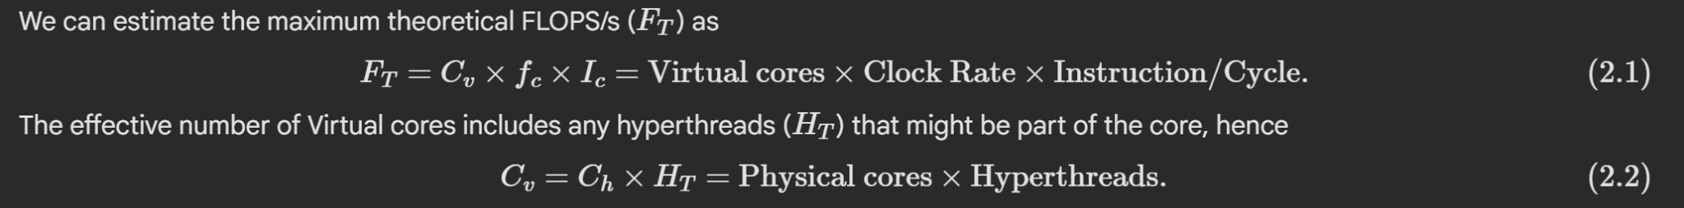

Fused Multiplier Add (FMA): a processor instruction that performs a multiplication and an addition in a single step (improves efficiency)

Base Vs Maximum Clock Rate: Base clock rate is sustained under full load, while maximum clock rate is achieved for short bursts depending on system load and temperature.

Word Size: the number of bits a CPU can process as a single unit (e.g., 32-bit for single precision, 64-bit for double precision).

Estimating Theoretical Memory Bandwidth:
Memory Bandwidth (B_{T}) dictates how fast data can be fed to the processor:

Arithmetic Intensity
the number of Flops that can be performed per second, will decrease as the Arithmetic Intensity decreases and more memory operations are required, for a given bandwidth.

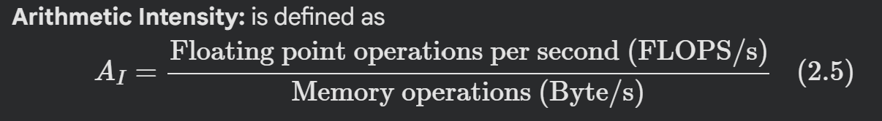

Therefore there is a limit of arithmetic intensity, above which the number of FLOPS/s is limited by the speed of the processor

Bandwidth-limited / Bandwidth-bound: when a program whose performance is constrained by memory bandwidth rather than by compute throughput (FLOPs). In other words, the processor spends most of its time waiting for data to arrive from memory, not performing arithmetic. This is often the dominant bottleneck for many scientific and data-intensive workloads
Compute-limited / Compute-bound: when a program's performance is constrained by the processor's ability to perform arithmetic operations, not by how fast data can be moved from memory.

Estimating Arithmetic Intensity and FLOPS/s
In-place operation: is one that overwrites its own input, rather than producing a separate out object. Significance of this is that no additional memory needs to be defined for the output, hence it tends to be faster.

Empirical Testing of Your Own Code
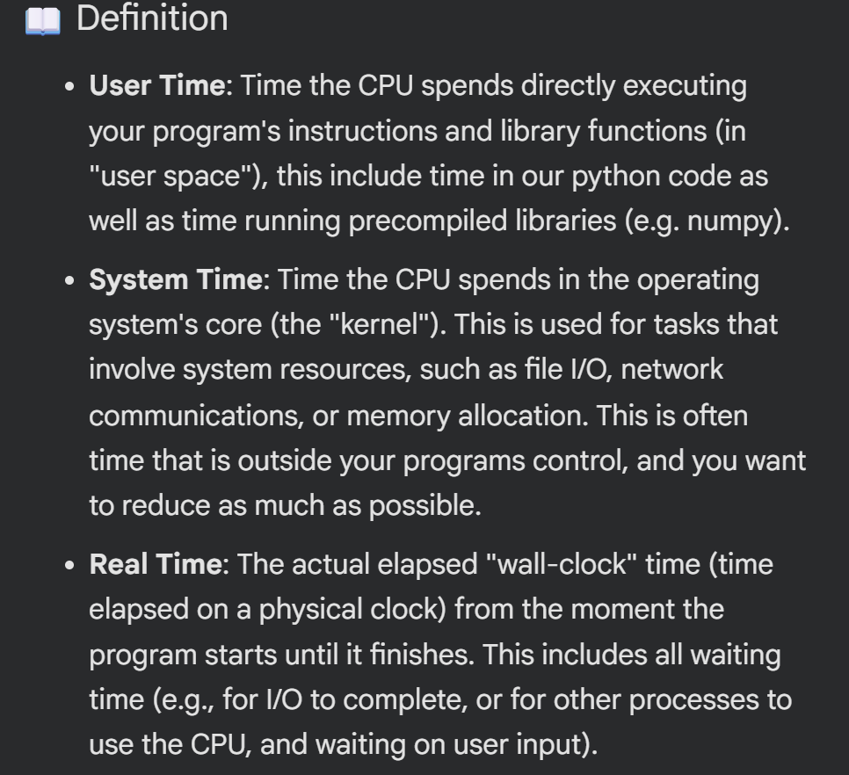

Profiling Code
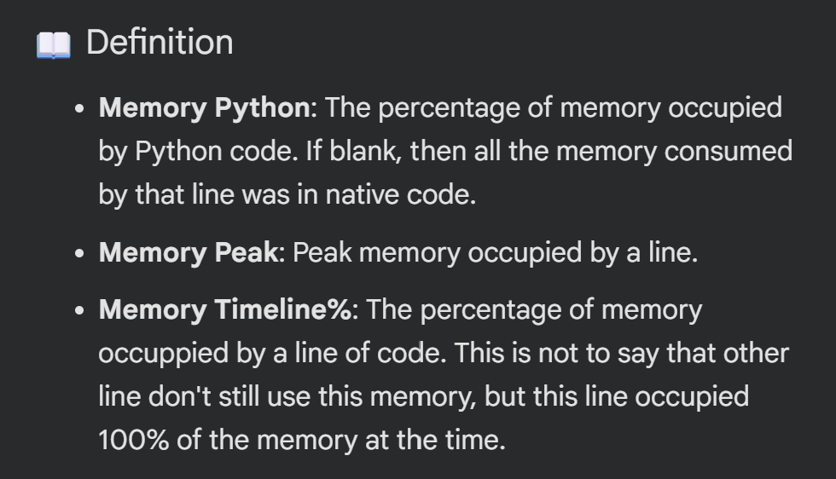

Numerical Errors
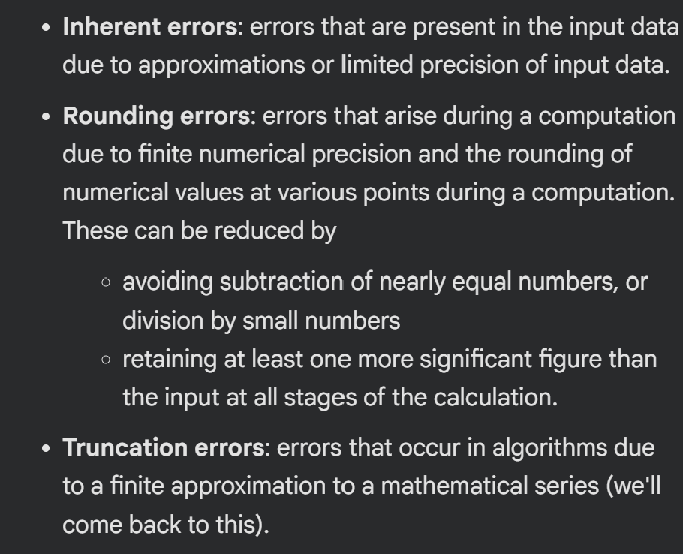

Propagation of Error
Or

Systems of Linear Equations

A Numerically Singular Matrix is one whose determinant is not exactly zero but is so close that computer calculations cannot reliably distinguish it from a truly singular matrix.

Numerical precision is a critical practical consideration. The choice of algorithm and even the number of variables (N) can drastically affect the reliability of solutions in real-world engineering problems.

Just different methods of solving and their computational benefits.

Week 3

Week 3 Notes
Interpolation and Machine Learning
INTERPOLATION vs EXTRAPOLATION

Interpolation: estimating inside the measured data range
Extrapolation: estimating outside the measured data range
Local Fitting: using nearby data points only
- Advantages: simple, predictable, robust for tabulated engineering data
- Disadvantages: be unsmooth, miss global trends, can give poor derivative estimates
Global Fitting: fitting one model across the whole data set
- Advantages: compact mathematics, smooth, captures broad trends
- Disadvantages: One changed data point can affect the whole curve, can oscillate bad (high-degree polynomial, Runge’s phenomenon), extrapolation can look correct but be physically wrong

COMPARISON OF 3 METHODS
- Local Linear Interpolation
- A piecewise linear interpolant, joins adjacent data points with straight lines
- Global Polynomial Interpolation
- A single polynomial passing through all data points
- Global Quadratic least-squares fit
- A single deg2 polynomial, doesn’t necessarily pass through all poitns

NOTE: Extrapolation should be supported by physics, extra validation data, or clear engineering assumptions.
- Interpolated plots were fairly similar, however the lines diverted clearly one beyond the set data range

HOW THE METHODS RESPOND TO A CHANGED DATA POINT
Local: mostly changes near the point effected
Global: can change everywhere

DATA NOISE AND OVERFITTING
Overfitting: If data contains noise, forcing a curve to pass through all points can make the curve learn the noise, not the underlying engineering behaviour.
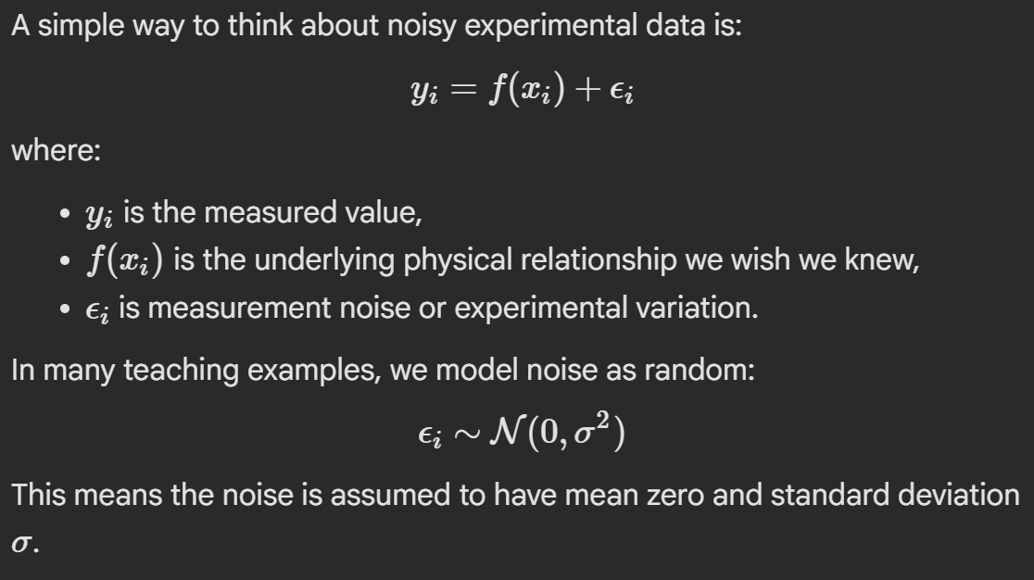
However, this is only an assumption. Real engineering data can contain a myriad of systematics errors;
- Sensor bias,
- Calibration errors
- Temperature drift etc

Exact interpolation: a curve that passes through every data point
Fitting / Approximation: a curve that captures the trend of the data, but doesn’t have to pass through every point.
Underfitting: when it is too simple to capture the important behaviour
Overfitting: when it's so flexible that it captures noise of random variation in the data
Generalisation: when it performs well on new data, not just the data it was built on

TRAINING ERROR vs VALIDATION ERROR

Training error: error measured on the data used to build the model
Validation error: error measured on separate data that was not used to build the model
- Validation data: a repeated wind tunnel run, a separate simulation, an additional sensor log, a benchmark case, etc…
NOTE: It is important to keep the validation data separate from model fitting, as the validation data can become a part of the modelling process

SPLINE BASED APPROACHES
- Exact cubic spline interpolation
- Passes through every point
- Smoothing spline
- Approximates the data while penalising excessive curvature

NEWTON POLYNOMIAL INTERPOLATION
- A polynomial that passes through a set of known data points.
- It can be built progressively using a divided difference table
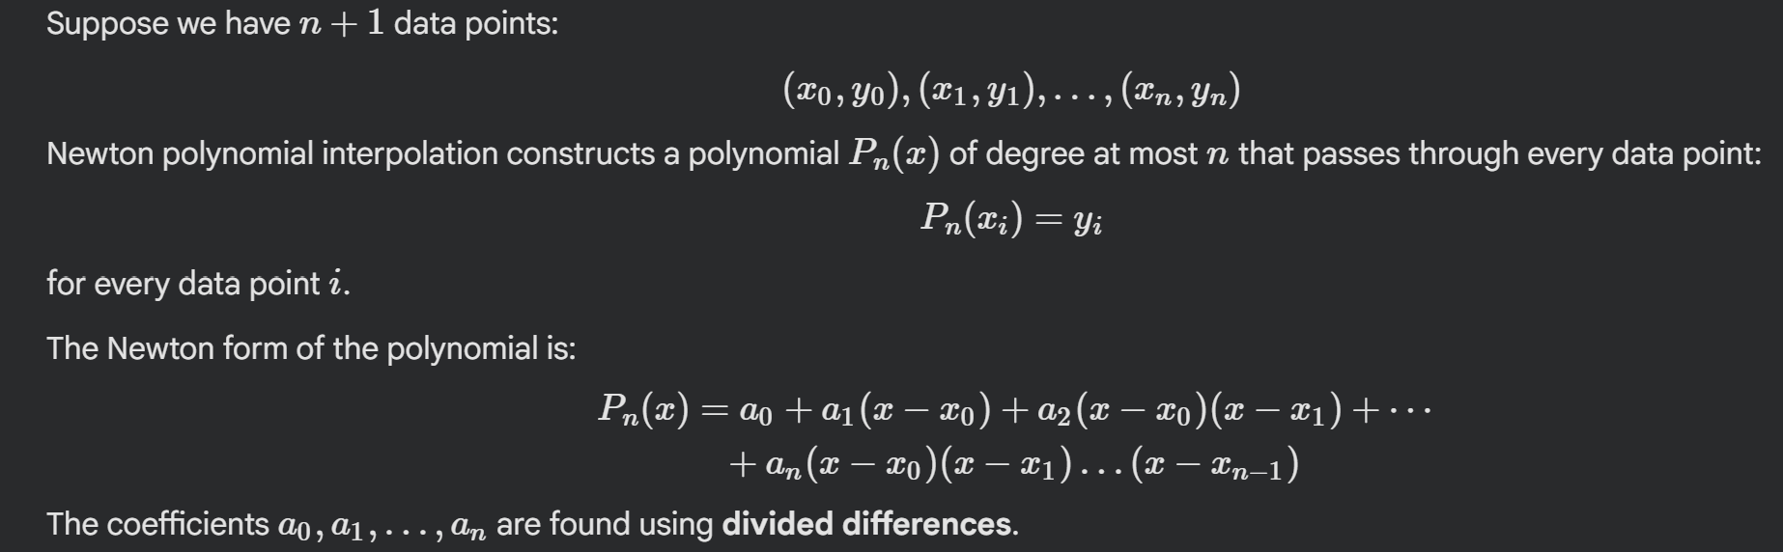
(same polynomial as lagrange interpolation)

DIVIDED DIFFERENCES
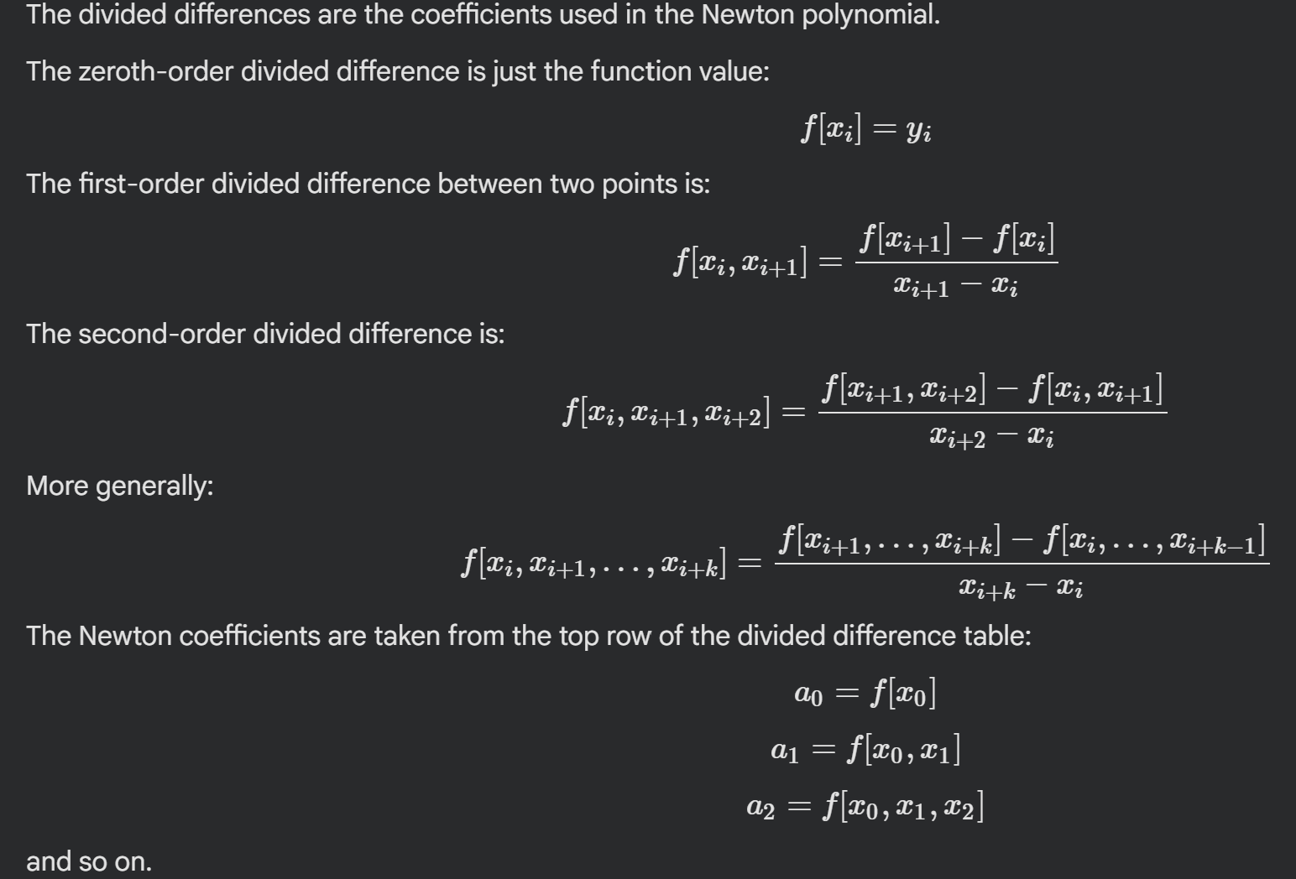

- Newton interpolation requires distinct x values
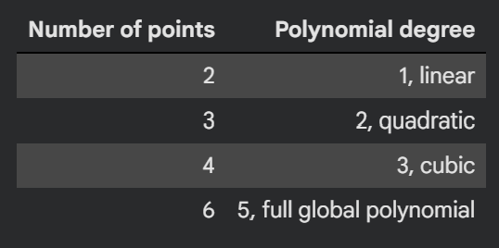

Practical advantage: if new data is added, the existing lower-order coefficients can be reused

SPLINE INTERPOLATIONS
- Smoother without one giant polynomial.
- Piecewise (low-degree) polynomials between neighbouring data points
- Polynomial pieces are joined together smoothly at data points

Advantages:
- Low-deg polynomial pieces
- Smoother results than linear
- Avoids high-deg polynomial issues
- Can be designed to preserve shape or monotonicity
- Works well for engineering lookup tables
Disadvantages:
- Requires choosing a spline type
- Boundary conditions can affect the result
- Exact splines can still overfit noisy data
- Smoothness doesn’t guarantee physical correctness

TYPES OF SPLINES
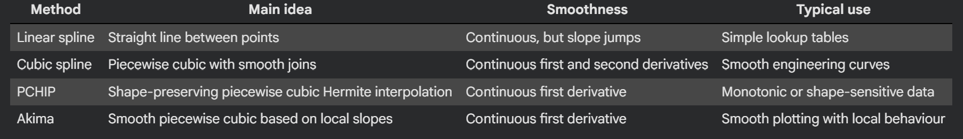
BOUNDARY CONDITIONS
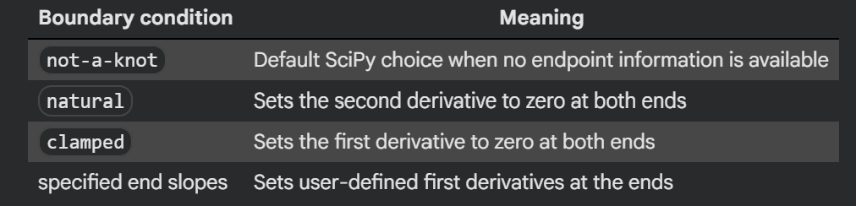
NOTE: PCHIP is often a good choice when preserving the shape of the data is important

SMOOTHING SPLINES FOR NOISY DATA
- Because they avoid unnecessary wiggles smoothing splines are preferred for noisy data
- Note; smoothing is a form of approximation

2D INTERPOLATION
- Estimating values of a function with two indepndent variables, e.g z = f(x,y)

Grid vs Scattered data
Grid: the data is arranged at all combinations of selected x and y values, and values are known at every pair.
Scattered: The data points are irregularly located.

SciPy recommendations
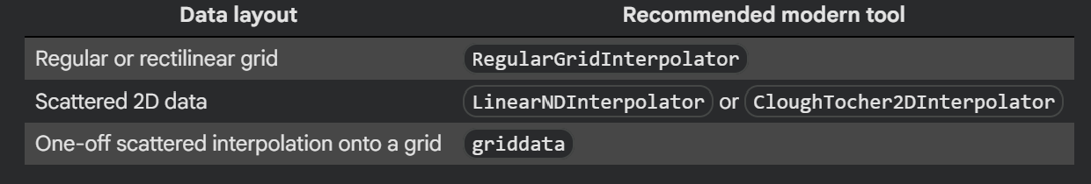

BUILDING A RegularGridInterpolator
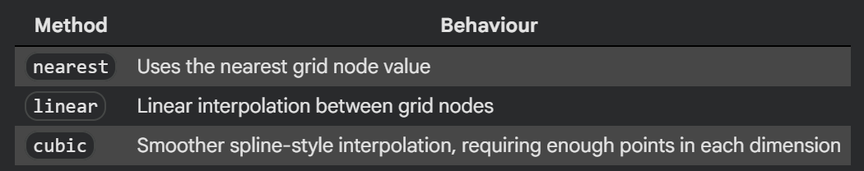
USING griddata (scattered data)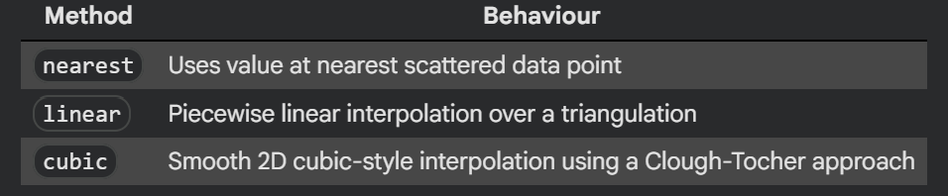

Convex hull: smallest convex region that contains all the data points

Use griddata for quick one-off interpolation
Use interpolator objects when you want to build once and evaluate many times.
- 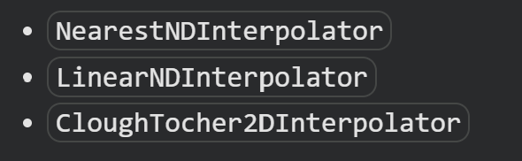

RADIAL BIAS FUNCTION INTERPOLATION
- Create smooth interpolating surfaces from scattered data
Results can depend on:
- kernel choice
- Smoothing settings

- Large data sets become computationally expensive
- Extrapolation could be misleading
NOTE: RBF plots the entire rectangular region, however this region might not be entirely supported by data so it's important to always check

SUMMARY OF METHODS
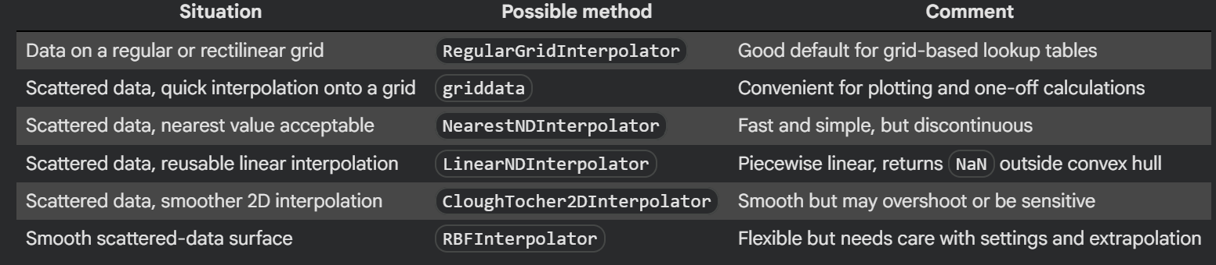

INTERPOLATION IN MACHINE LEARNING

Many machine learning regression models are not exact interpolators

LOCAL, GLOBAL AND PROBABILISTIC ML-STYLE INTERPOLATORS
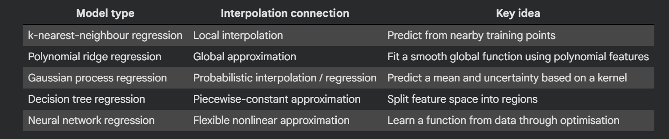

Changing the value of k
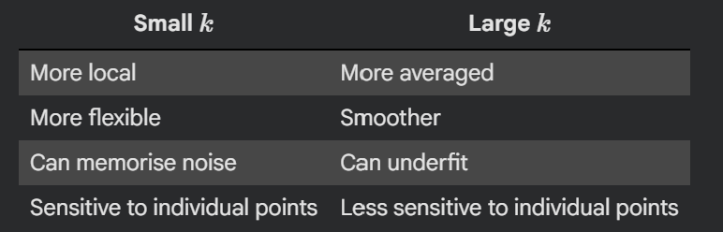

METHOD SELECTION SUMMARY: 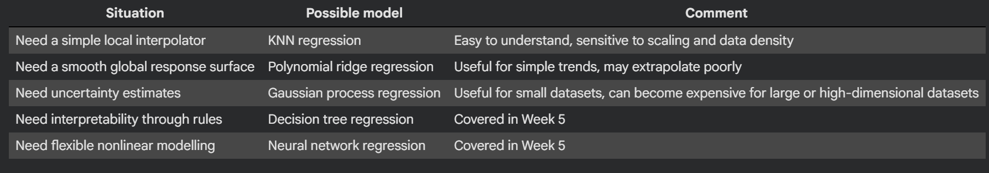

W3 Practical Project Component
Chosen specific question: Can environmental sensor measurements (CO₂, temperature, humidity, PM2.5) from a room be used to predict whether that room is occupied at a given time, and can the model indicate when a prediction falls outside what the data supports?

1. Quantity obtained only at discrete locations or operating conditions
Occupancy itself (e.g., via a people-counter or door sensor) is recorded only at the discrete timestamps the system samples, not continuously between readings.
2. Domain in which a prediction is supported
The model can only be trusted for the same room (or rooms) and the same range of operating conditions seen in training, normal weekday building-operating hours across the dates covered by the extract. It is not supported for that room during unusual conditions (holidays, HVAC shutdowns, overnight) or for any room that wasn't instrumented and included in training.
3. Data geometry classification
Multifeature — each observation pairs a vector of environmental inputs (CO₂, temperature, humidity, PM2.5, time-of-day, day-of-week) with an occupancy label/count, rather than sitting on an ordered 1D axis or a regular grid.
4. Baseline method vs. more flexible comparison
- Baseline: K-nearest-neighbour classification/regression on CO₂ and time-of-day alone, simple, interpretable, a natural sanity check since CO₂ rises with occupancy.
- Flexible comparison: Gaussian-process regression (or classification) using the full feature set — can capture nonlinear interactions between variables (e.g., CO₂ rising faster in poorly ventilated rooms) and provides an uncertainty estimate alongside each occupancy prediction.
5. Validation test and physical constraint
- Validation: Withhold a contiguous block of time (e.g., the last 1–2 weeks) not used in training; compare predicted occupancy against logged/observed occupancy over that period using accuracy, precision/recall, or RMSE if occupancy is a count.
- Physical constraint: Occupancy cannot be negative, and predicted occupancy should not exceed the room's known physical capacity; predictions outside this range are physically implausible and should be flagged regardless of what the model outputs.
6. Behaviour for an unsupported query
Before returning an occupancy estimate, the code checks whether the query's time and feature values lie within the training data's coverage (e.g., time-of-day range, CO₂/temperature range seen for that room). If the query falls outside this range, a new room, an unseen time period, or an unusual combination of sensor readings, the code returns an explicit "unsupported" flag rather than extrapolating silently and presenting an unvalidated number as if it were reliable.
7. Provenance, units, settings, and AI assistance
- Provenance: NEMo Cloud platform data for room "69_G.57_Living Lab 1" (or the specific rooms in the final extract), with extraction date noted once the detailed dataset is provided.
- Units: CO₂ in ppm, PM2.5/PM10 in µg/m³, temperature in °C, humidity in %RH, occupancy as headcount or binary occupied/unoccupied, timestamps in ISO 8601.
- Method settings: record k for KNN, kernel and hyperparameters for the Gaussian process, and the exact train/validation time split used.
- AI assistance: disclose which parts of the code or write-up were drafted or debugged with AI assistance, and confirm all outputs were checked against the real dataset before being reported.

Week 4
Week 4

Test Yehawwww

Week 5

Prework

Linear Regression

Core language
- Sample: one observed engineering case
- Feature: an input used to make a prediction
- Target: the output we want to predict
- Model Parameter: learned from the training data
- Prediction: the model output 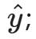
- Residual: the observed value minus the prediction
- Training Data: used to estimate the model params
- Validation Data: withheld from fitting and used to check generalisation
- Baseline: a simple reference that a useful model should outperform

Note: ‘linear’ means linear in the parameters. E.g: 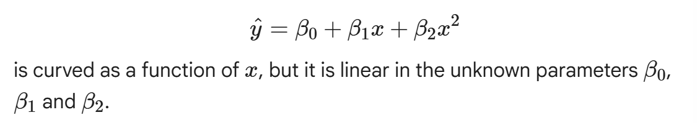

Random Split checks whether the nodel predicts similar unseen samples form the same data set, it doesn’t prove the model will work for;
- A different sensor
- A different temp range
- Forces outside calibration range
- A changed data-acquisition system
- Future data after the sensor has drifted

Work flow for fitting a linear regression model
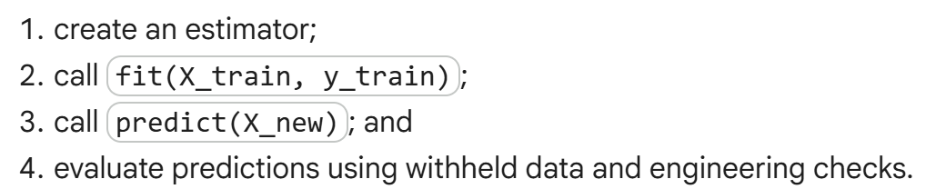

Predictions and Residuals
- A prediction is only useful when we understand its error
- Positive residuals: observed force is larger than predicted
- Negative residuals: observed force is smaller than predicted

Validation Metrics and Baseline
- MAE: Mean absolute error (in target units)
- RMSE: Root mean squared error (in target units and more sensitive to larger residuals)
- R^2: The fraction of target variation explained relative to a mean prediction reference

Note: A high R^2 doesnt guarantee that:
- The model is unbiased
- The errors are acceptable for engineering decision
- The model will extrapolate safely
- The relationship is causal
- The data represents future operation conditions
- Error must be judged using units, tolerance, consequences and the intended use

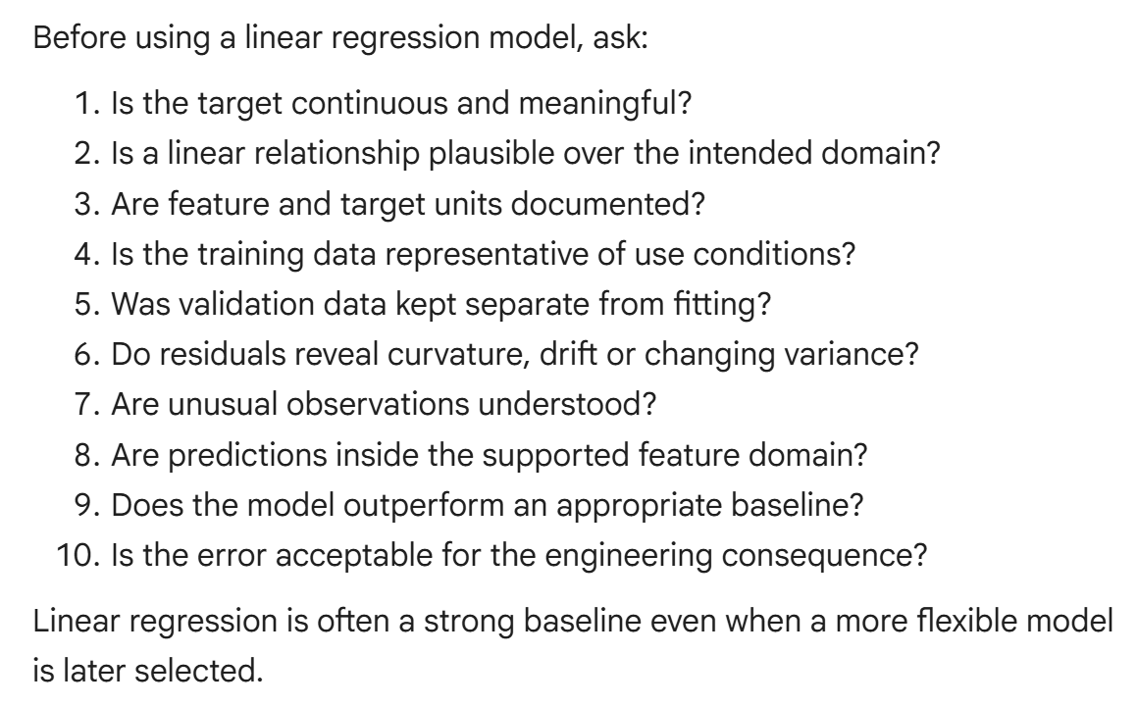

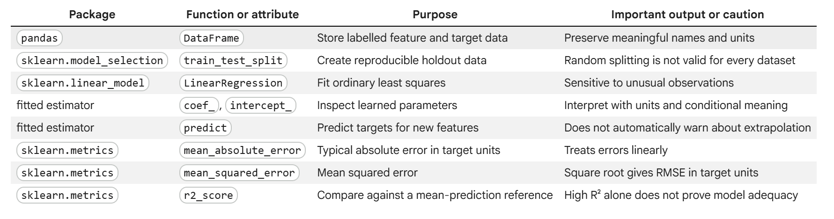
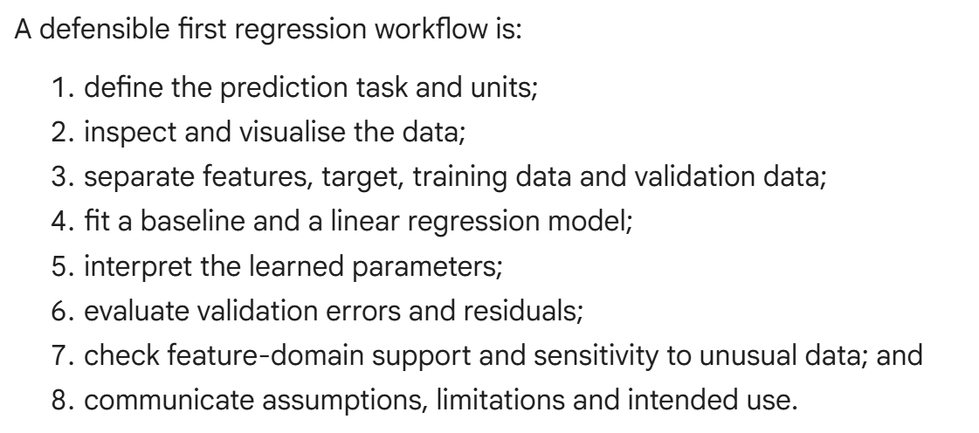

Decision Tree Regression
Decision Tree Regressor: Learns a sequence of threshold rules and predicts a constant value inside each final region
- Easy to visualise
- Creates important limitations; step-like predictions, weak extrapolation and a strong tendency to overfit when the tree grows out of control

Core language
- Node: contains a subset of training samples
- Split: applies a rule
- Branch: one outcome of a split
- Leaf/Terminal node: a region where the tree makes a prediction
- Depth: the number of split level from the root to a node
- Impurity: measure target variation inside a node
- Pruning/Regularisation: limits tree complexity
- Piecewise Constant: means the prediction is constant inside each leaf region

How a tree makes a prediction
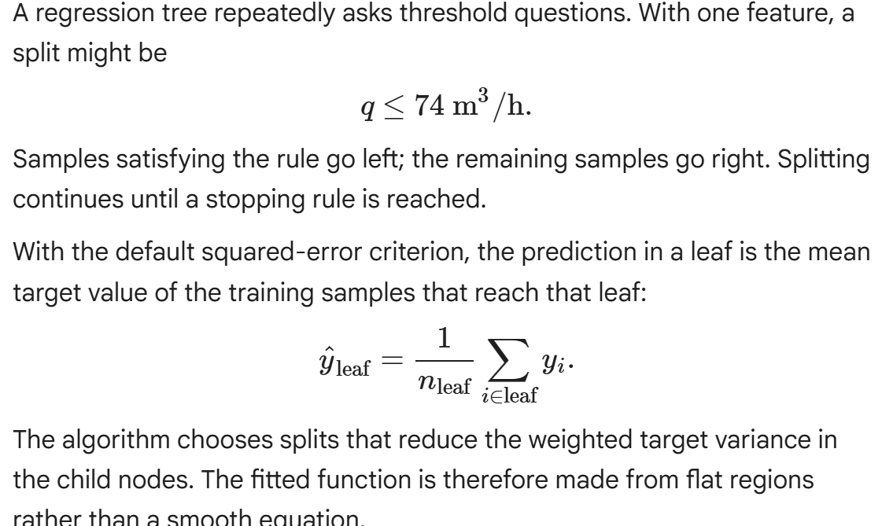

Example:
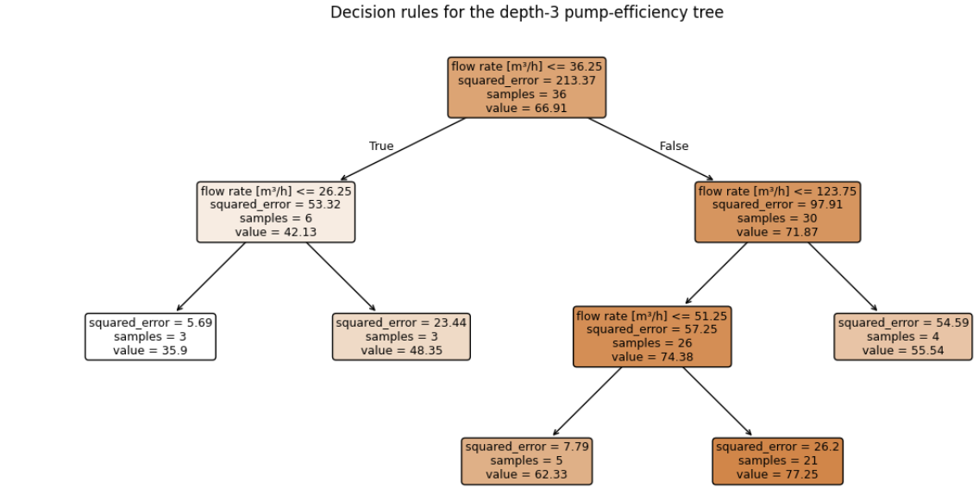

A shallow tree may underfit by merging distinct operating regions
A very deep tree may overfit by creating small leaves around measurement noise. E.g.

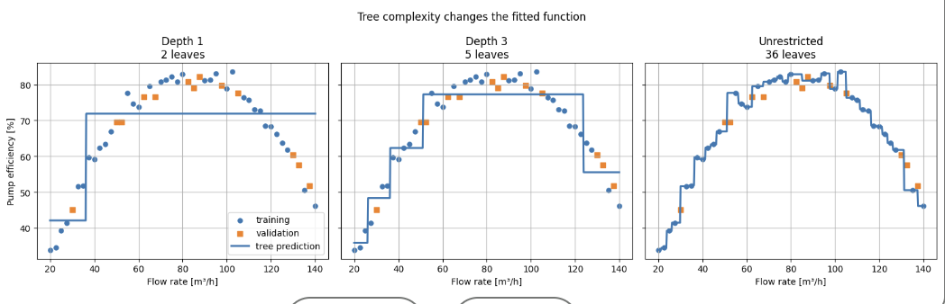
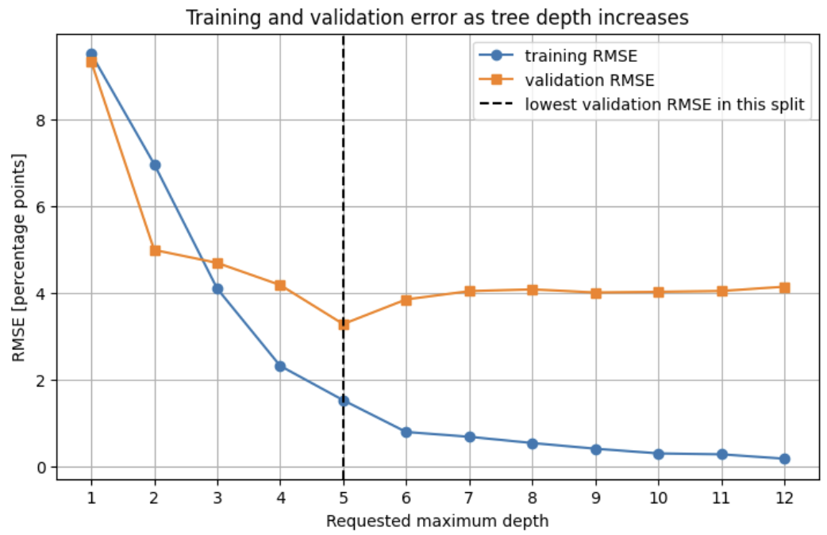

Extrapolation:
As there are no new splits beyond the data set, the prediction remains at the value of the boundary leaf

Permutation Importance: measures how much validation performance decreases when one feature is shuffled.

Shuffling: breaks that features relationship with the target while leaving the fitted tree unchanged

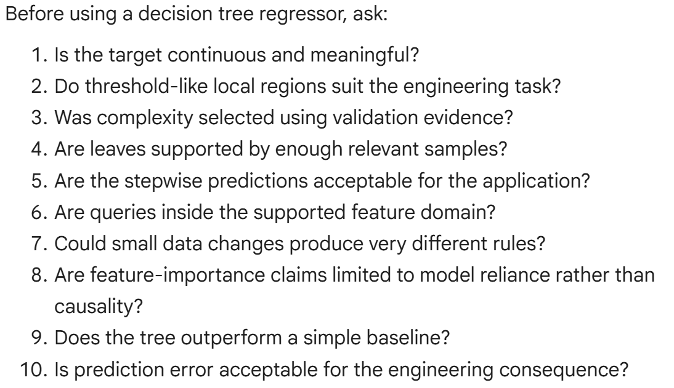

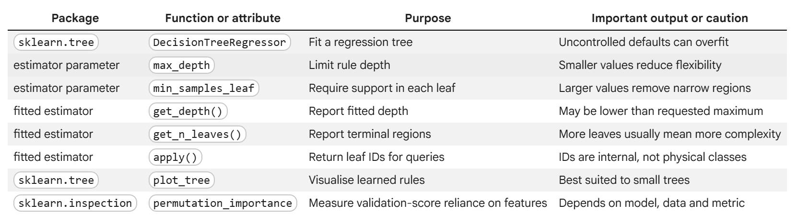

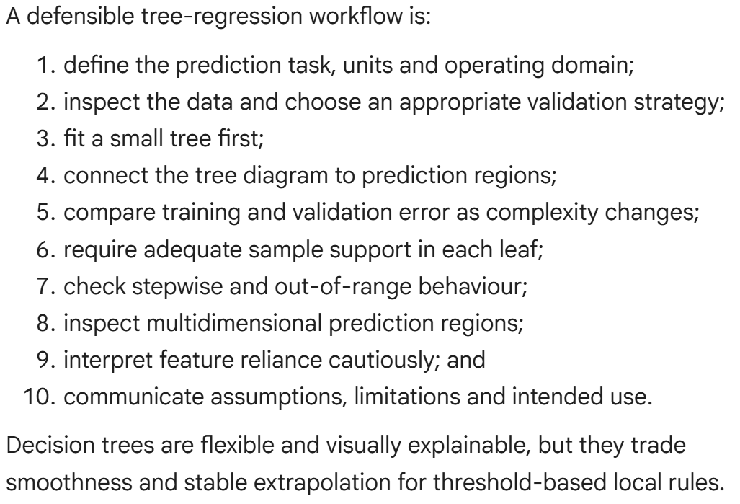

Support Vector Regression
- Can fit a smooth nonlinear relationship while allowing a chosen band of small errors
- Effecting for moderate datasets and nonlinear responses
- Flexibility makes future scaling, hyperparameter selection, validation, and domain checks essential.

Epsilon-insensitive idea
If wee demanded that hte curve pass as close as possible to every measurement, it could react to small measurement noise instead of learning the underlying relationship.
- SVR lets us define an acceptable vertical error band around its prediction curve.
- This band = epsilon tube
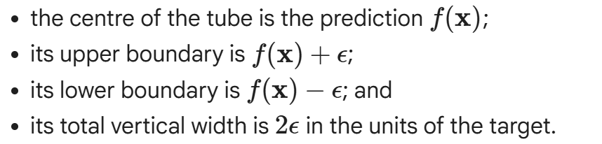
Only part of error beyond the tube is counted.

Core language:
- Kernel: measures similarity between feature vectors
- RBF Kernel: allows a smooth nonlinear prediction without explicitly adding polynomial columns
- Support Vector: a training sample retained in the fitted SVR solution
- C: Controls the trade-off between a flatter model and errors beyond the tube
- Epsilon: sets the tube half-width and target units
- gamma: controls how local the influence of an RBF support vector is .
- Scaling: Puts features on a comparable numerical scale before evaluating the kernel.

RBF Kernel
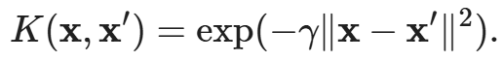

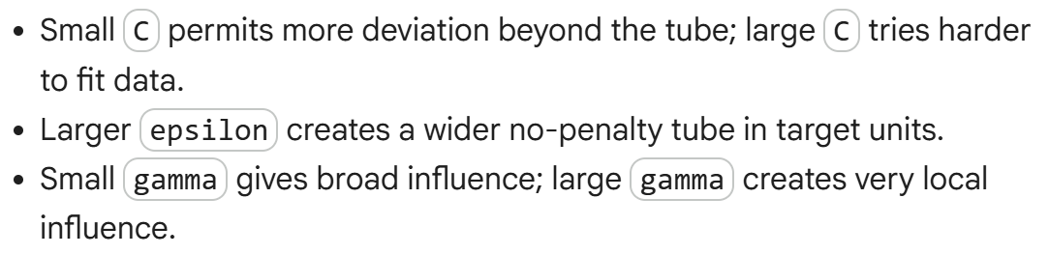

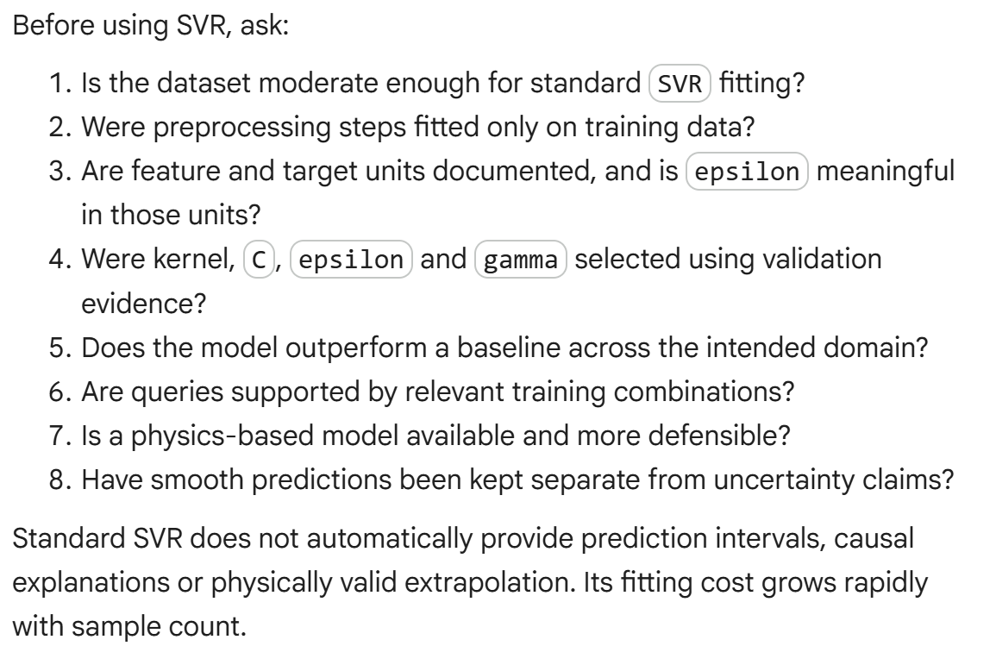

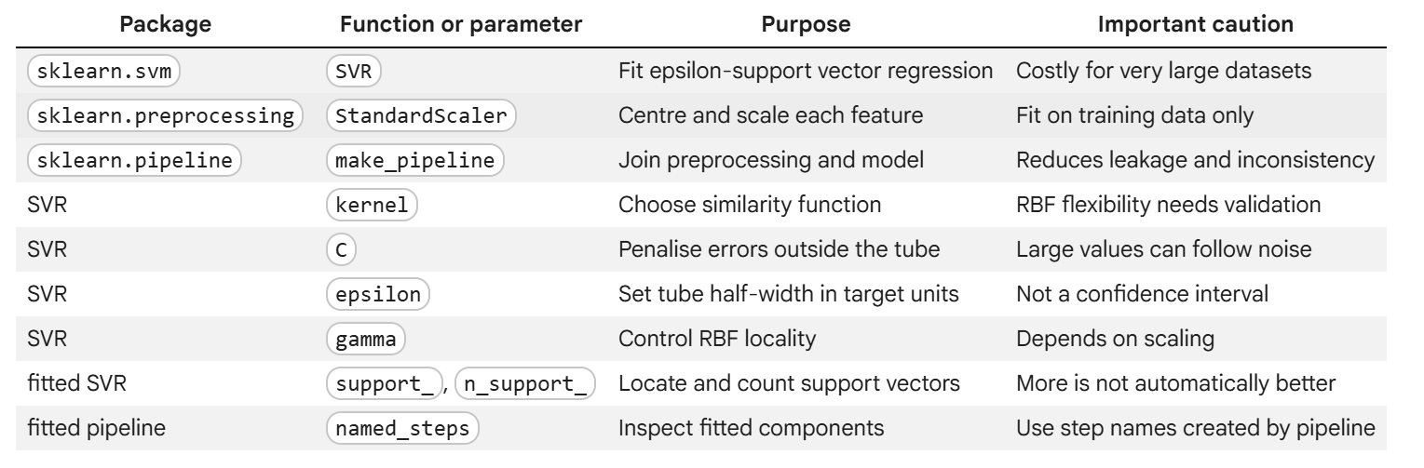

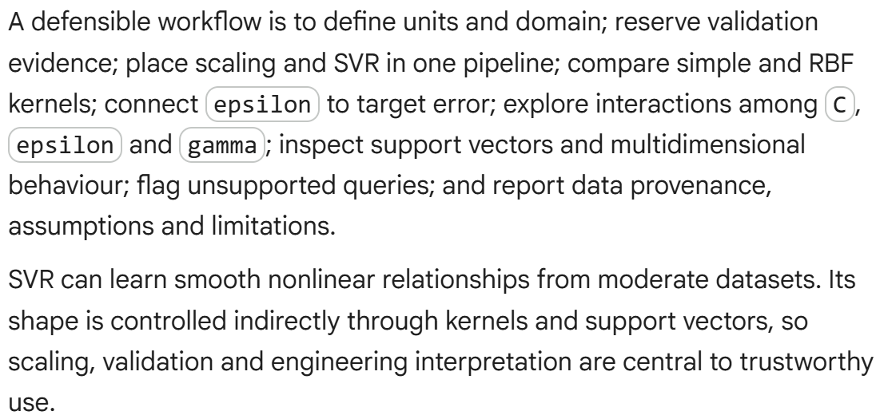

Neural Network Regression
- A network receives numerical input features, transforms them through one or more hidden layers and produces a continuous output.
- 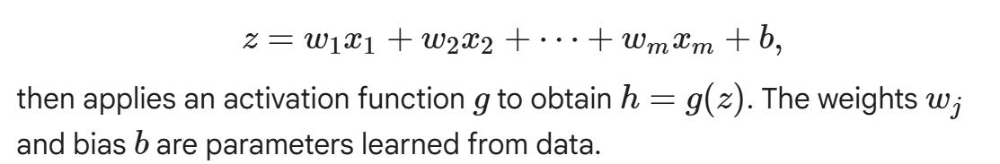
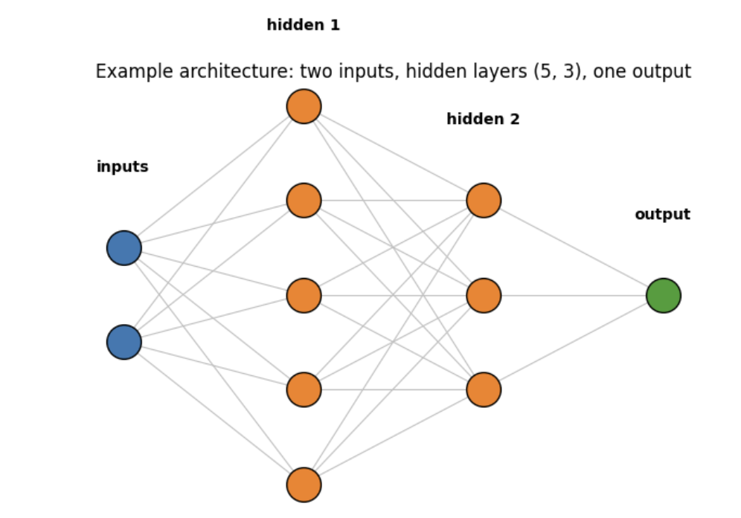

Forward Prediction: passes features through the current weights to calculate 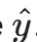
- Training then compares the predictions with targets using a loss.
- 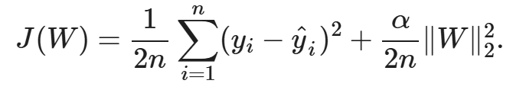
Backpropagation: calculates how the loss changes with each parameter.

- A 2d relationship cannot be judged completely by a single scatter plot

- A network represents the interaction and saturation without receiving their equations

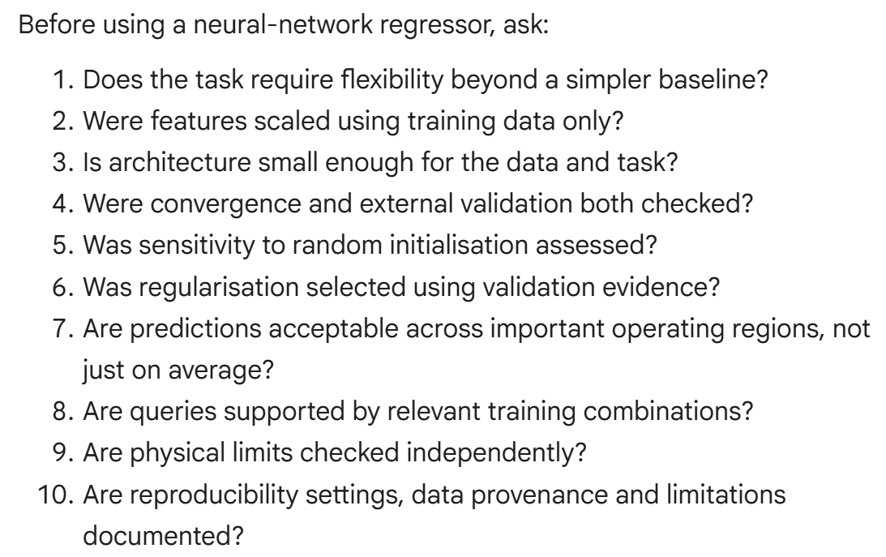
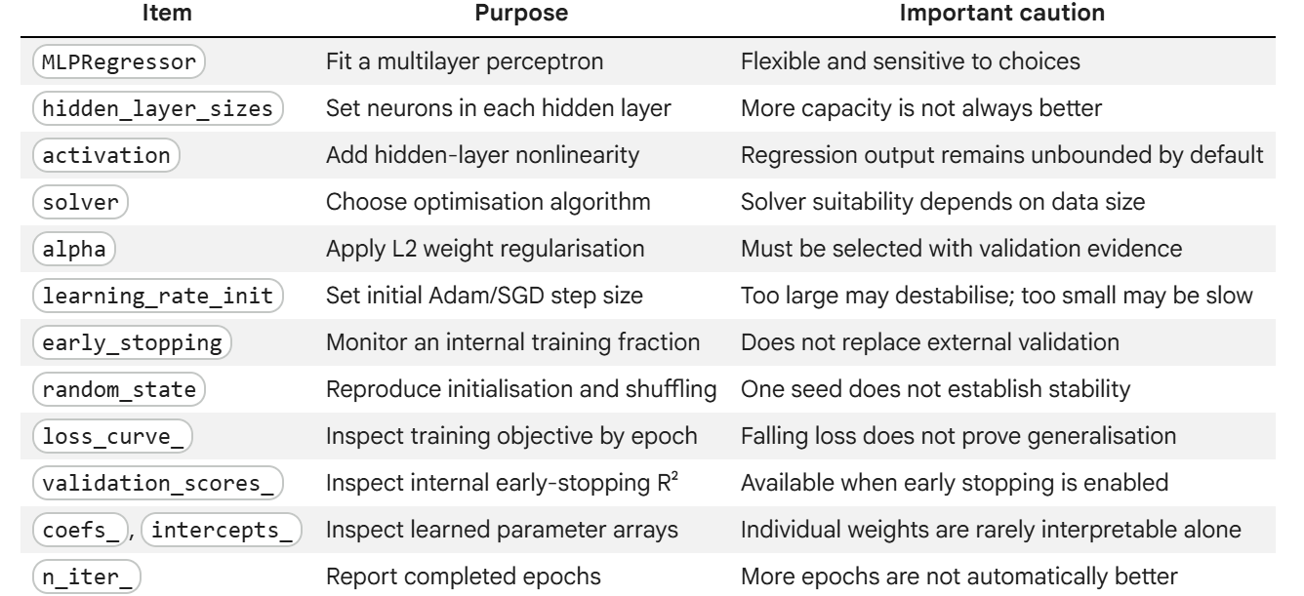

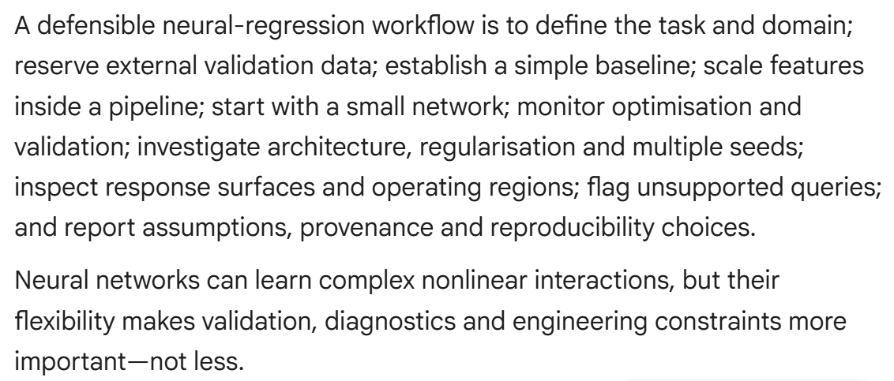

Evaluating Regression Performance
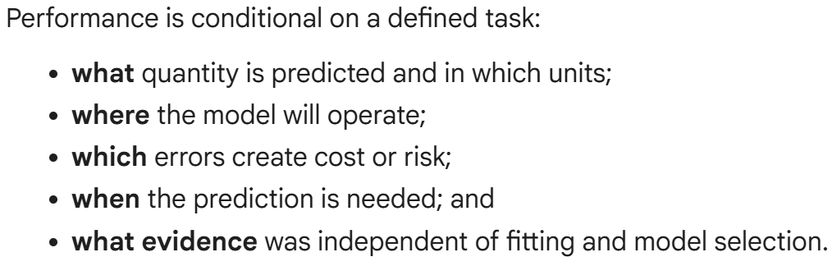

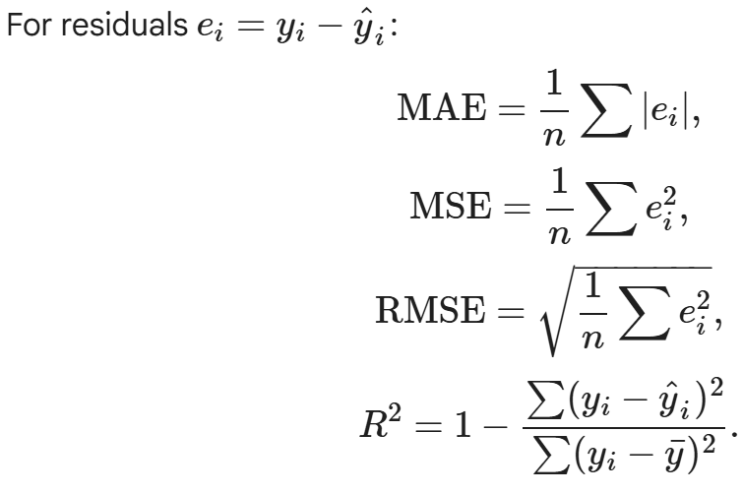

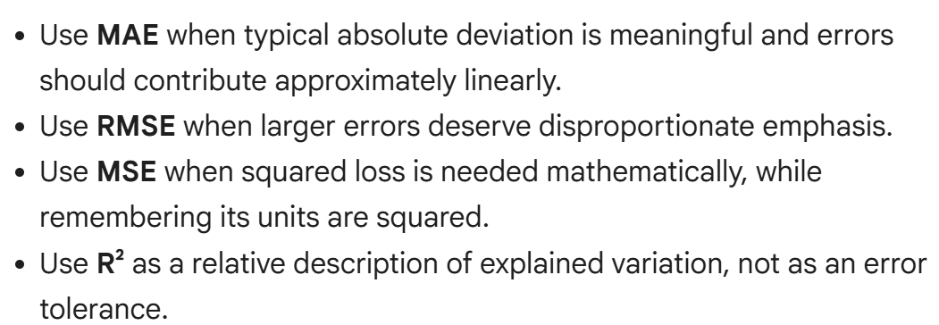

If R^2 is negative, it means the model is worse under squared error than predicting the evaluation-set mean for every observation

Training, validation and final-test roles
- Training Data: estimate model parameters
- Validation Data: compare methods and hyperparameters
- Test Data: provide one final evaluation after choices are fixed

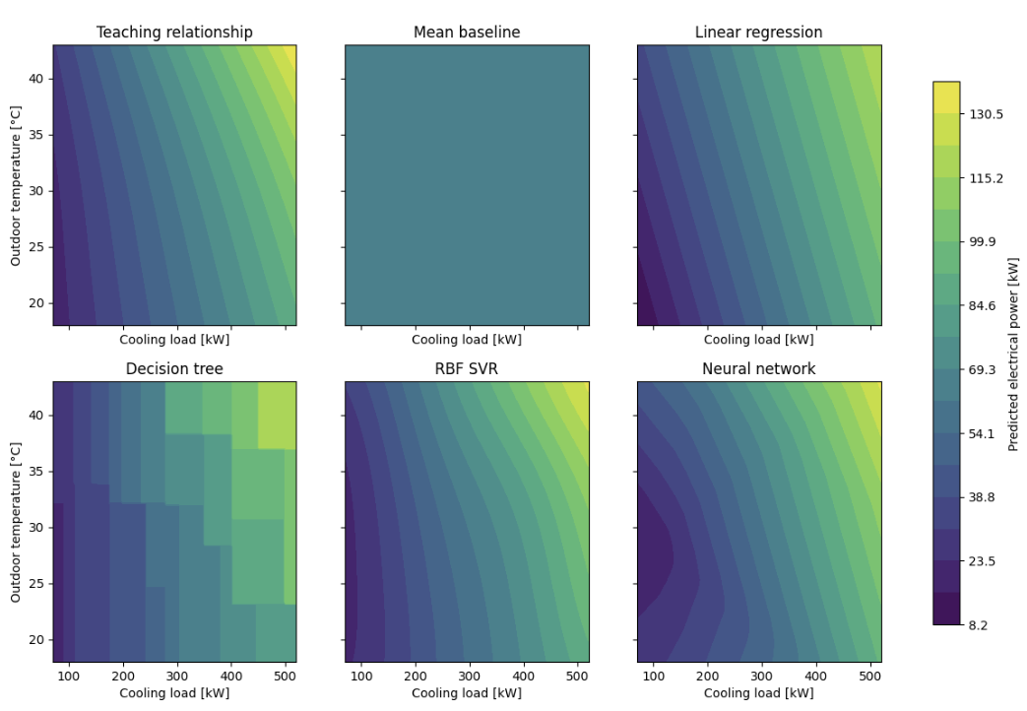
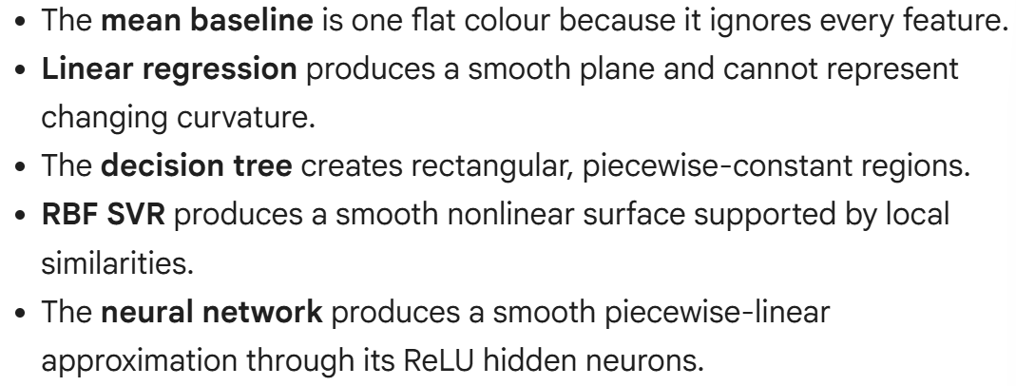

Residuals:
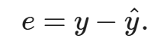

A positive residual means the model underpredicted
A negative residual means the model overpredicted

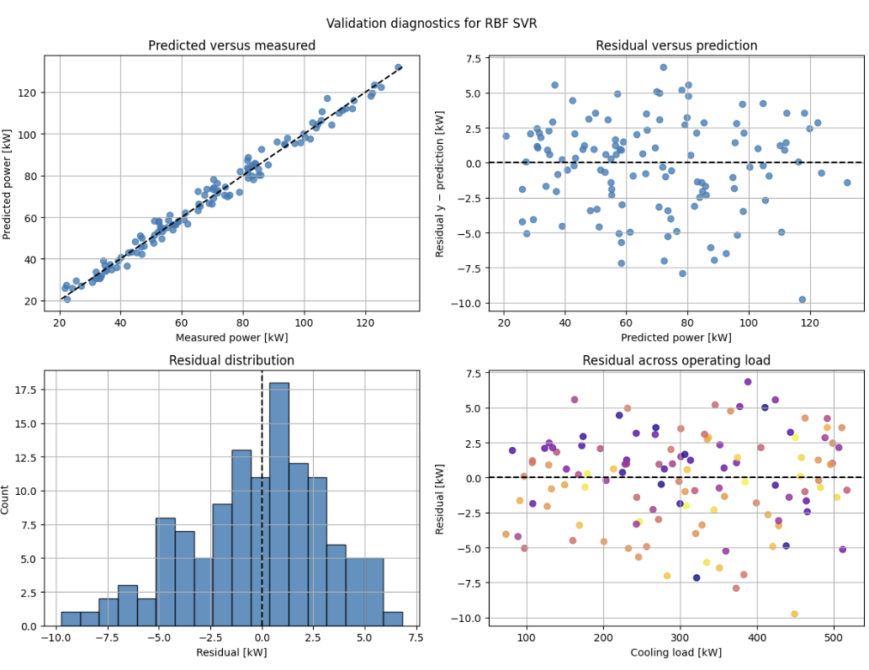

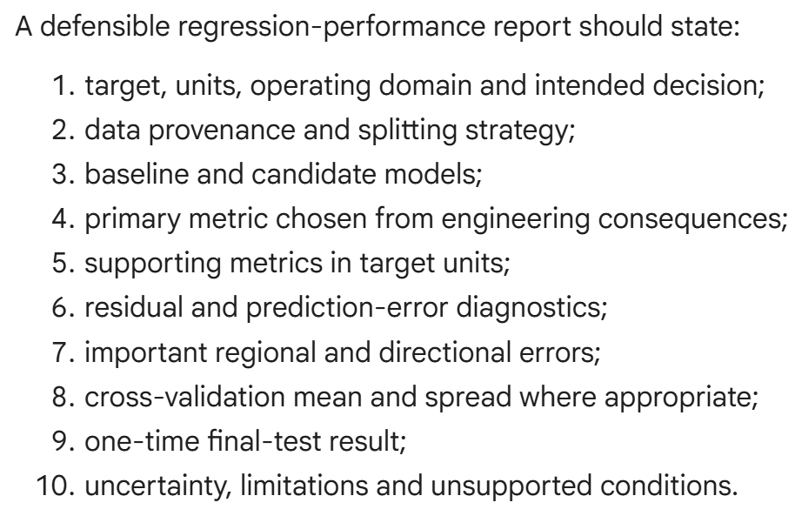
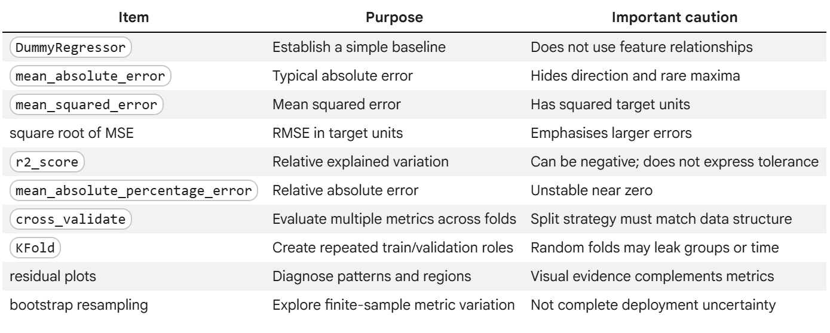

Training Data Evaluation and Selection
Define what the model is intended to do:
- Unit of observation: what real-world case does one sample, data point or row represent.
- Target: what quantity is predicted, and what time, in what units
- Availability inputs: what will genuinely be known when the prediction is made
- Deployment population: which assets, sites, seasons, operating regions matter
- Decision & cost: how will the prediction be used, and what happens when it is wrong

Answers combined into a prediction contract

EXAMPLE:
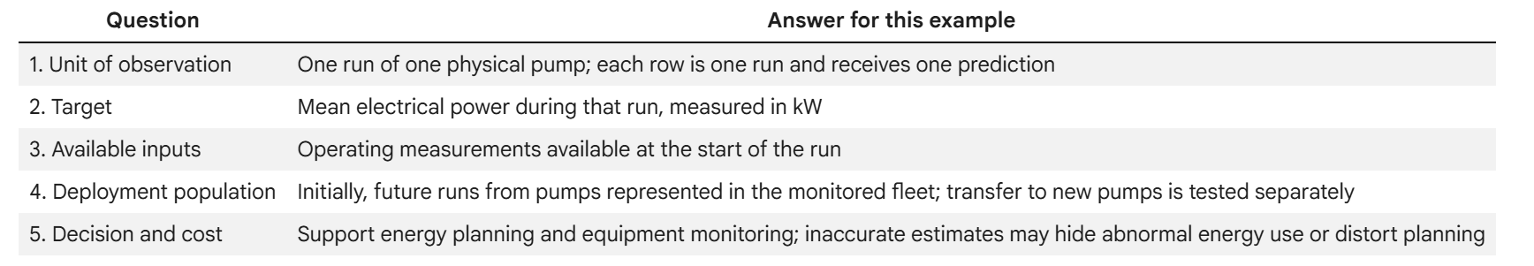
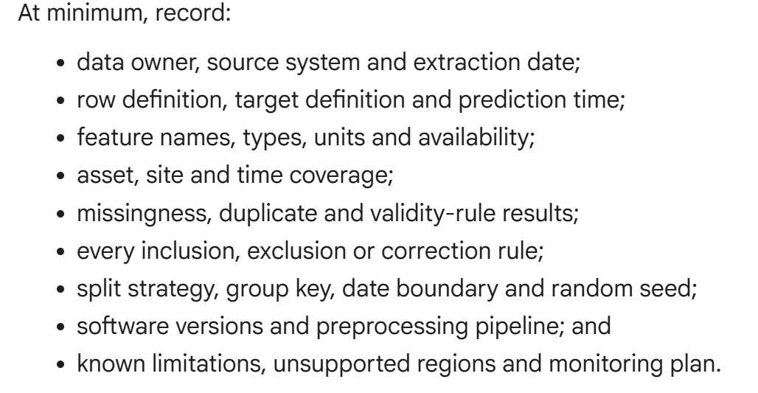
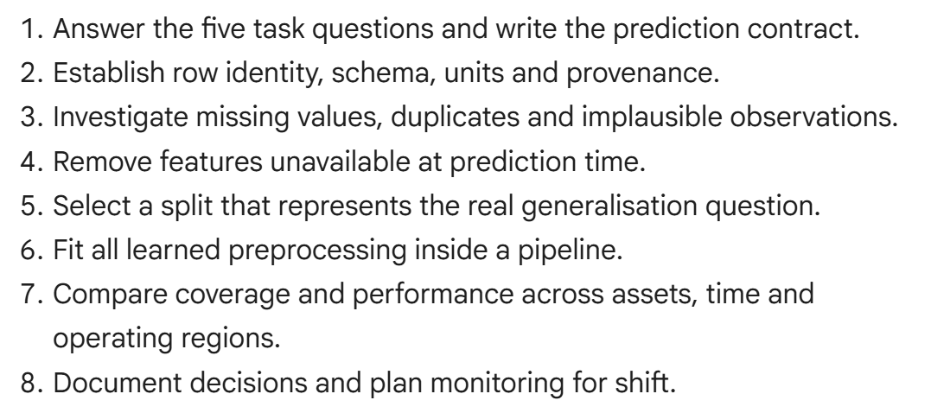
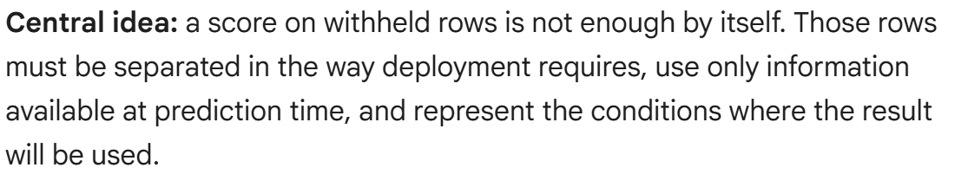

W5 Practical Project Link
1. Unit of observation
One timestamped reading from a single room's environmental sensor package (e.g., "69_G.57_Living Lab 1" at a given 5–15 minute interval), consisting of CO₂, temperature, humidity, PM2.5, and the corresponding occupancy label/count for that same timestamp.
2. Target and prediction time
Target: occupancy state (or headcount) in the room. Prediction time: the current timestamp, using only data available up to and including that moment — this is a nowcasting problem, not a forecast into the future.
3. Features genuinely available at that time
CO₂, temperature, humidity, and PM2.5 readings up to and including the current timestamp; time-of-day and day-of-week derived from the timestamp itself; and short-window trends (e.g., CO₂ rate of change over the last 15–30 minutes) computed only from past readings — no data from after the prediction time.
4. Baseline and candidate models
Baseline: K-nearest-neighbour regression/classification using CO₂ and time-of-day only. Candidate: Gaussian-process regression using the full feature set, chosen for its nonlinear flexibility and built-in uncertainty estimate.
5. Split strategy matching deployment
Time-based (chronological) split — train on an earlier contiguous block of weeks and validate on a later, held-out block — never a random shuffle, since deployment means predicting forward in time on data the model has never seen, and random splits would leak future information into training.
6. Metrics, critical operating regions and failure consequences
Metrics: classification accuracy/precision/recall (or RMSE if occupancy is a count) on the held-out period, broken out separately for building-operating hours vs. off-hours. Critical operating region: occupied periods during core working hours, where a false "unoccupied" reading could wrongly trigger ventilation or lighting shutdown while people are present — the highest-consequence failure mode.
One-sentence retraining trigger: If validation performance degrades noticeably after a change to the room's usage pattern, HVAC/ventilation system, or sensor placement — or if residuals show a sustained bias rather than random scatter — that is evidence the model no longer reflects current conditions and should be retrained or rejected.

Week 6

Prework
6.1 Newton-Cotes Integration
When only sampled values are available, Newton-Cotes rules approximate the integrand between sample locations and integrate that approximation

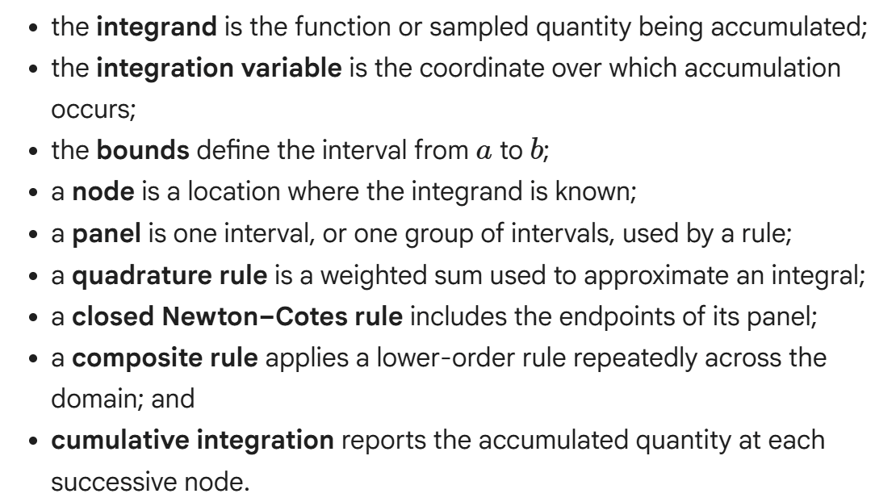

The Neton-Cotes rules follow three steps:
- Choose equally spaced nodes in an interval
- Construct a polynomial through the sampled values
- Integrate that polynomial exactly
The result:
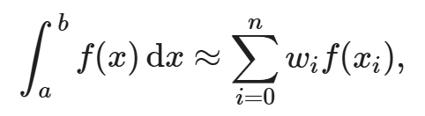
The weights w_i depends on the node locations and selected rule.
Composite rules:
- Trapezoidal (straight segments)
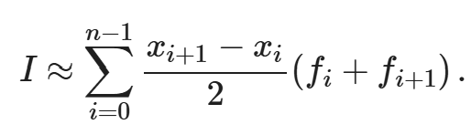
- Simspon ⅓ (local quadratics)
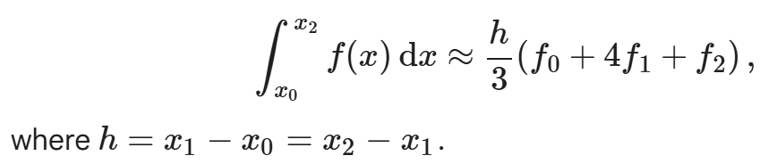
Note: Simpson ⅓ rule is often more accurate for smooth functions with equally spaced data, but it is not automatically superior when measurements are noisy, poorly ordered or too sparse to represent important behaviour.

Cumulative Integration
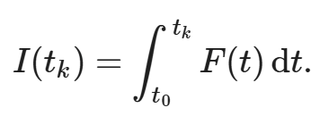

Note: Trapezoidal deals with unequally spaced points well whereas Simspon does not

Order and Sign:
- Increasing coordinates integrate from left to right
- Decreasing coordinates reverse the bounds and change sign
- Shuffled coordinates create a path that jumps forwards and backwards

Method Limitations and engineering checks:
- What physical quantity is being accumulated?
- Are the integrand, variable, bounds and output units documented?
- Are the coordinate and measurement arrays paired and correctly ordered?
- Are missing, duplicated or invalid samples understood?
- Does the selected rule satisfy its spacing and sample-count requirements?
- Are the samples dense enough to represent peaks, oscillations and transitions?
- Is the result sensitive to using a different defensible rule or subset?
- Is independent reference information available for validation?
- Does the reported precision reflect the quality of the data and method?
- Which conclusions remain unsupported by the numerical integral?

6.2 Errors in Newton-Cotes Methods
What does I mean here:
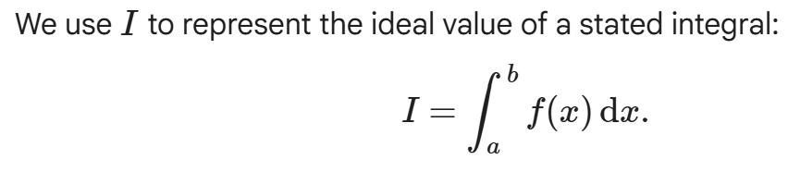
For a real experiment the true physical value of I cannot usually be measured directly.
Focus on;
- What the symbols mean
- What happens when the sample spacing is reduced
- Which assumptions make an error result valid
- What a calculation can and cannot claim about a real system

- The exact integral I is the mathematical value of the stated integral.
- A quadrature estimate Qh is the value returned using spacing h.
- Quadrature error is I−Qh and comes from replacing the integrand between nodes with an approximation.
- Absolute error ignores the sign; relative error scales error by |I|
- Order of accuracy describes how rapidly error decreases as h→0
- A rule's degree of exactness is the highest polynomial degree it integrates exactly, apart from floating-point effects.
- A refinement study repeats a calculation with progressively smaller h
- The asymptotic range is the region where the leading theoretical error term dominates and the expected convergence rate is visible.

Error Map: reported result−physical truth=quadrature contribution+data contribution+model/scope contribution+round-off contribution

By the given convention
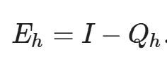
Eh > 0 means the estimate is too small, while Eh < 0 means it too large
Common reported magnitudes
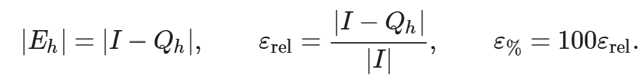
For equally spaced nodes:
- the trapezoidal rule is exact for polynomials up to degree 1; and
- Simpson's 1/3 rule is exact for polynomials up to degree 3.
Composite error formulas;
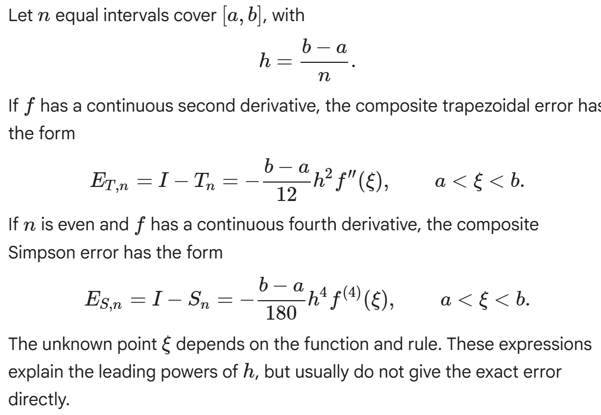
I.e. The Simpson error should be reduced by 2^4 = 16.

- A fixed integration interval
- Equally spaced nodes for these classical composite formulas
- The required continuous derivatives
- A valid panel arrangement, including even n for composite simpson ⅓ and
- Sufficiently small h for the leading error terms to deminate
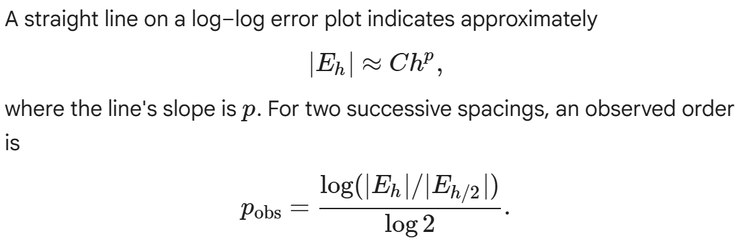
Note: this uses exact error, thus it is a verification test

Error bounds;
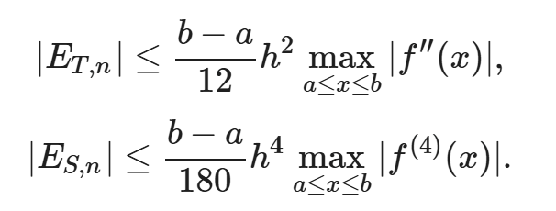
Since xi is unknown, replace a derivative value by a maximum over the interval.
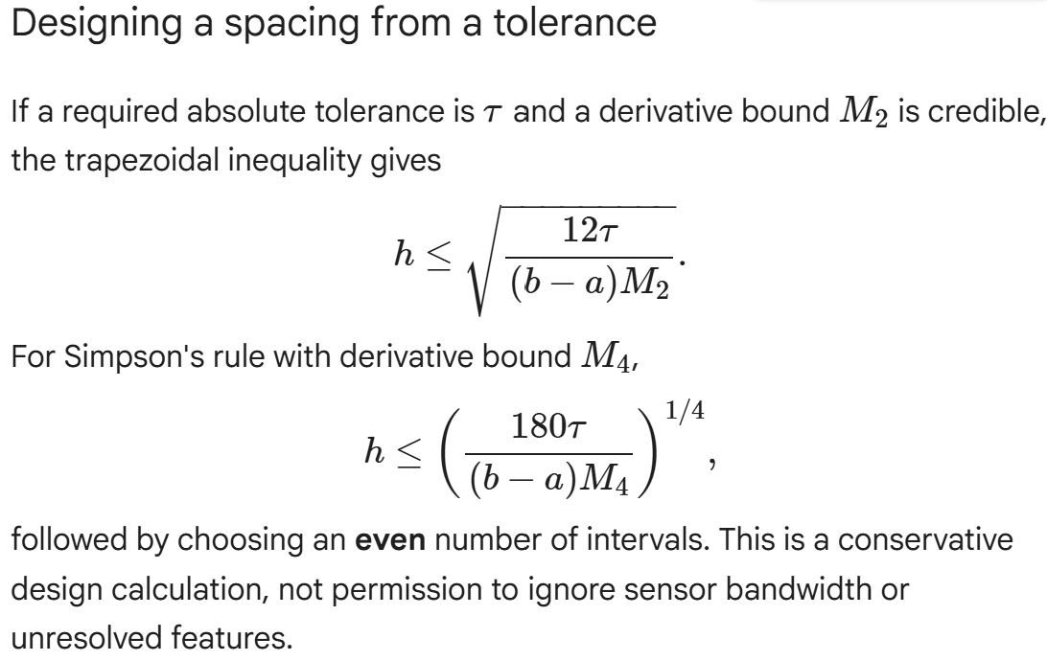
Key result: for sufficiently smooth functions on valid equal grids, composite trapezoidal error behaves as O(h^2) and composite Simpson error as O(h^4) . Those are conditional convergence statements. They do not guarantee that sampled experimental data represent the physical signal

Romberg integration and Richardson Extrapolation

Can you provide a comprehensive summary of this notebook. It should be around a 15 minute read and include all of the key definitions and concepts

Romberg Integration and Richard Extrapolation
- Improve accuracy of integral estimates by systematically cancelling errors
- Carefully organised refinement sequences can yield significantly better estimates from reusable samples

Leading Error Term: the dominant part of the error when the step size h is small. For trapezoidal rule, this is O(h^2)
- By scaling and subtracting a coarse estimate from a fine one we can create a new estimate that behaves as if it had a much higher order of accuracy.

Richardson Extrapolation Formula
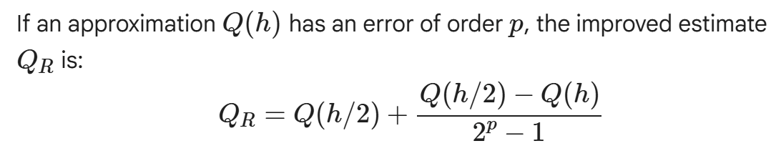
- Connection to Simpson’s Rule; applying one step of richardson extrapolation to a trapezoidal estimate (where p=2) yields the same result as simpson ⅓ rule.
- Simpson’s rule is effectively a ‘pre-packaged’ version of error cancellation

Romberg integration: The Structurer Table
- The systematic, repeated application of Richardson extrapolation
- Builds a triangular romberg table R_k,j
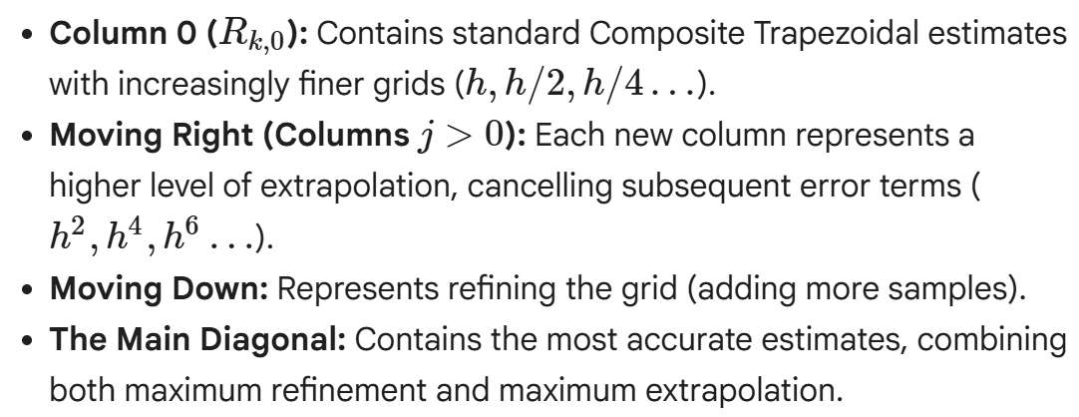

Implementation Requirements and Sample Reuse
Romberg - efficient because of Nested Grids
- When you halve the spacing you keep all old points and only add the new midpoints
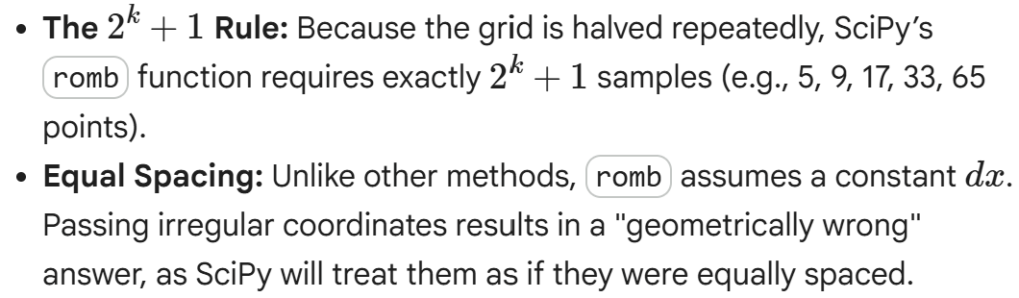
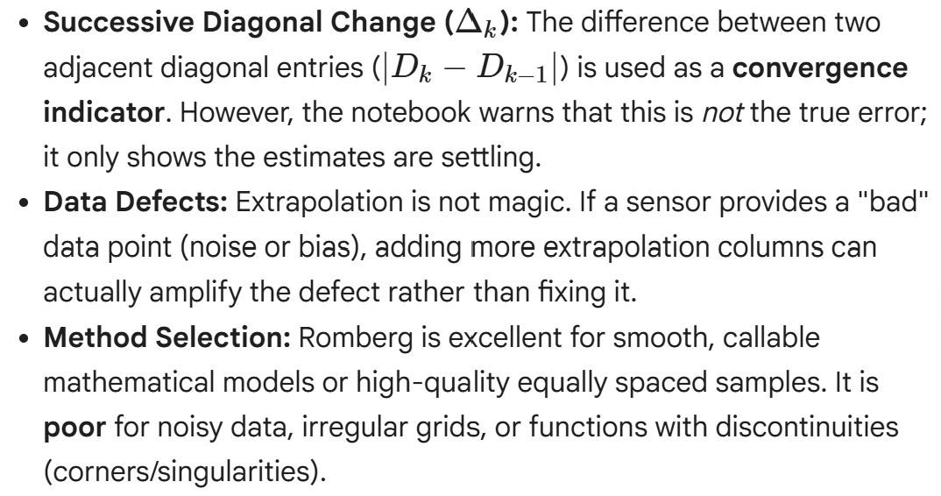

Gaussian Quadrature
Gauss-Legendre Quadrature:
- Unlike newton-cotes, Gaussian Quadrature intelligently selects both the nodes and the weights to achieve high accuracy fro a broad class of function

- Gaussian Quadrature: a ,method for numerical integration where both the integration points (nodes) and their corresponding multipliers (weights) are chosen optimally to maximise the accuracy of the approx
- Gauss-Legendre Quadrature: The standard Gaussian rule applied to finite intervals, typically normalised to the standard interval ([-1,1])
- Standard Coordinate: coord on the normalised interval ([-1,1])
- Physical Coordinate: coord on the real-world integration interval ([a,b])
- Quadrature Node: a specific coord where the integrand function is evaluated
- Quadrature Weight: a coefficient that multiplies the function value at a particular node in the weighted sum of approximation
- Quadrature order: the number of Gaussian nodes and weights used in the approx. Equiv to the number of function evaluations
- Polynomial Exactness: An (n)-point Gauss-Legendre rule exactly integrates every poly of degree up to (2n-1) (ignoring floating point errors). This is a significant advantage over other methods, which have lower degrees of exactness for the same number of evals
- Open rule: Gauss-Legendre Quadrature does not use the endpoints of the integration interval as nodes
- Coordinate Transformation: a mathematical mapping used ot transform the standard nodes, from [-1,1] to physical nodes on an arbitrary interval [a,b] - Rescale weights by a factor of (b-a)/2
- Composite Gaussian Quadrature: a technique that divides the overall integration interval, [a.b] into several subintervals (panels) and applies a low-order Gaussian rule within each panel. This is particularly useful for functions with localised features or non-uniform behaviour.

- Node Selection: Gaussian nodes are not arbitrary, the are the roots of the Legendre polynomial of degree n. This property is crucial for achieving high polynomial extractness.
- Efficiency: For smooth functions, Gauss-Legendre Quadrature offers superior accuracy per function eval compared to other methods.

Limitations and considerations
- Existing Data: Gaussian quadrature is most effective when the integrand can be evaluated at chosen locations. It is generally not suitable for existing, fixed, or irregularly spaced sensor measurements, as the measured points typically won't coincide with the required Gaussian nodes.
- Non-Smoothness: The high polynomial exactness relies on the function being smooth. Corners, discontinuities, singularities, or high oscillations can reduce its advantage. In such cases, splitting the integral at these problematic points or using composite quadrature may be more effective.
- No Error Estimate: Functions like scipy.integrate.fixed_quad return the approximation but not an error estimate, meaning you need other ways to assess convergence (e.g., comparing results from different orders).

Multidimensional Integration
- Quantities distributed across more than one coordinate
- E.g. pressure across a surface, density through a volume etc

- Domain (Ω): The specific area or volume over which the integration is performed.
- Integrand: The distributed quantity being accumulated by the integral.
- Iterated Integral: A method of evaluating a multidimensional integral by performing a sequence of one-dimensional integrals, one inside the other.
- Inner Bound: In iterated integrals, a bound that may depend on the outer coordinate, particularly for non-rectangular domains.
- Resultant: A single equivalent total load that replaces a distributed load.
- First Moment: A distributed quantity weighted by a coordinate, used to locate the line of action of a resultant force (e.g., center of pressure).
- Tensor-Product Rule: A method that combines one-dimensional numerical integration nodes and weights across multiple coordinate directions to approximate a multidimensional integral.
- Sampled Grid: Data consisting of values measured or simulated at specific combinations of coordinate vectors.
- Array Axis: Identifies which dimension of an array corresponds to a particular coordinate.
- Cubature: The general mathematical term for numerical integration in multiple dimensions.

Tensor-Product Gauss-Legendre Quadrature
1D Gaussian rules can be combined to form a tensor-product approximation
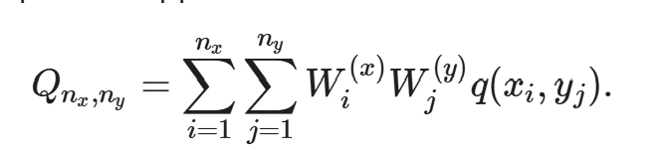

This method requires n_x*n_yfunction evaluations. An example demonstrates that for polynomial integrands, a low-order rule can yield exact results. Convergence is explored for a more complex, localized pressure feature, showing that accuracy may not improve monotonically at lower orders and highlighting the importance of inspecting convergence across several justified orders.

4. Coordinate-Dependent Bounds: Triangular Plate
For non-rectangular domains, such as a triangle, the integration bounds for the inner integral depend on the outer coordinate. dblquad handles this by accepting a callable function for the inner bounds. The example calculates the area and resultant force over a triangular region, emphasizing the importance of plotting and validating the domain.

5. Existing Values on a Sampled Rectangular Grid
When data is available on a sampled grid (e.g., from experiments or simulations), scipy.integrate.trapezoid can be used. The notebook illustrates how to integrate sequentially along array axes, highlighting that array shape alone does not convey physical meaning; coordinate vectors, indexing conventions, and axes must be documented together.

6. Extending to Three Dimensions: scipy.integrate.nquad
The concept is extended to triple integrals for calculating the mass of a component with varying density. scipy.integrate.nquad is used, which expects bounds to be listed from the innermost to the outermost coordinate, and the callable arguments to follow the same order.
The Curse of Dimensionality
A critical consideration for tensor-product rules is the rapid growth of evaluation cost with increasing dimensions. If n nodes are used in each of d dimensions, the total evaluations are N_eval=n^d
. This exponential growth, known as the curse of dimensionality, makes tensor products impractical for high-dimensional problems, necessitating alternative methods like adaptive cubature, sparse grids, or Monte Carlo techniques.

✅ Validation and Method Selection

Validation Checks:
The notebook provides a comprehensive list of validation checks to ensure reliable results:
- Integrate 1 to confirm the known area or volume.
- Use uniform fields to verify symmetry with geometric centers.
- Track units through each integration step.
- Compare results by reversing integration order.
- Compare callable function results with sampled-grid implementations.
- Refine node order or grid spacing to inspect convergence.
- Compare against analytical solutions, conservation laws, or finite-element results.
- Crucially, plot the field and domain to visually confirm correct setup, as agreeing numerical values can still stem from incorrect models or domains.

Method Selection:
A table guides the selection of appropriate methods based on the data source and domain geometry:
- Smooth callable on a rectangle: Tensor Gaussian or adaptive cubature.
- Callable with simple variable bounds: dblquad or nquad.
- Existing complete rectangular grid: Repeated sampled-data integration (e.g., trapezoid).
- Triangular or curved region: Coordinate-dependent bounds or coordinate transformation.
- Scattered measurements: Interpolation, meshing, or specialized methods.
- Many dimensions: Adaptive, sparse, or sampling-based methods.

Common Interpretation Failures:
The notebook also lists common pitfalls, such as swapping dblquad arguments, using incorrect bounds, integrating along the wrong array axis, or misinterpreting error estimates as physical uncertainty.

Week 7

Prework

Finite Differences and Ordinary Differential Equations
7.1 Finite-Difference Representation of Derivatives

Generate a 15 minute read summary of this notebook and embed it as a text block at the top of the notebook. Provide a comprehensive overview of all key concepts discussed in the note book and include all necessary definitions + equations.

Using finite differences to estimate engineering rates + gradients from sampled data
When analytical differentiation is not possible.

Finite Difference: An apporiximation of a derivative using values at discrete points
Coordinate: location or time at sample i
Step Size, h: the distance between neighboring coordinates on a uniform grid
Stencil: Specific set of neighboring samples used by a finite-difference formula
Derivative Estimate D_i: The numerical approximation to the exact derivative f’(x_i)
Boundary: the first or last coordinate where samples are only available on one side
Order of Accuracy p: How quick;y truncation error decreases as h decreases, 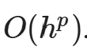

For a uniform grid x_i = x_0 + ih
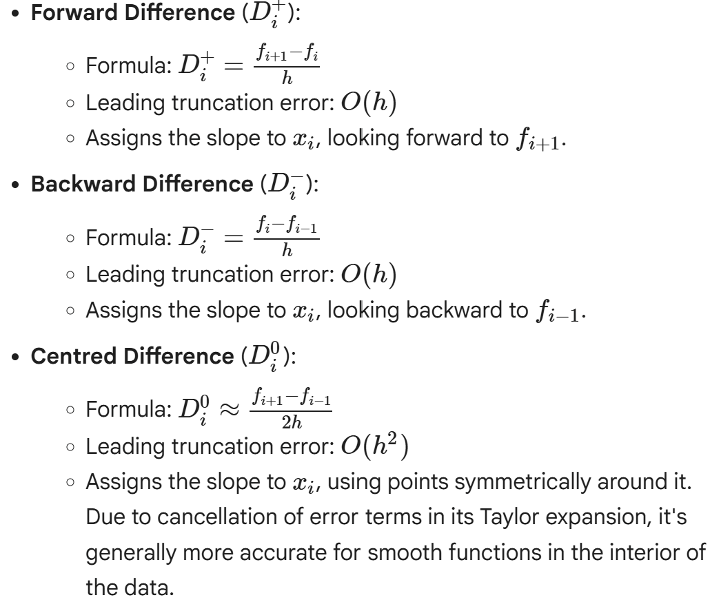
Centred differences cannot be used at the first or last samples because they require data on both sides. Solutions:
- Omitting boundary derivatives
- Using first-order forward/backward differences
- Using wider, one-sidded stencils (e.g. second-order one-sided formulas 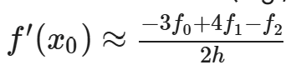(for the left boundary)

Second derivatives:
Acceleration from position, can be estimated using a centred second difference
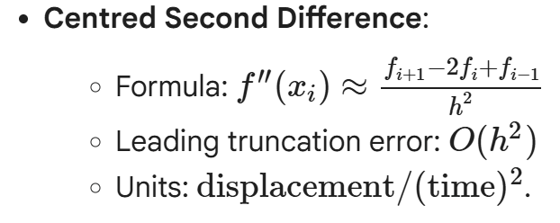
Calling np.gradient twice can also compute second derivatives, but this can amplify errors from the first differentiation step. (maybe do this first in my assignment if need be then change it to show improvement hehehe
numpy.gradient – is a robust tool for numerical differentiation. The preferred call is derivative = np.gradient(f, x, edge_order=2)
- Supplying Coordinates: Always provide the coordinate array x (e.g., time t) to np.gradient. Omitting it (np.gradient(f)) assumes unit spacing, leading to incorrect magnitudes and units (e.g., change per sample instead of m/s).
- edge_order: This argument controls the order of accuracy for the one-sided boundary formulas. edge_order=2 is a common and usually suitable choice.
- Non-uniform Coordinates: np.gradient correctly handles non-uniform spacing when the coordinates array is provided, calculating local weights based on actual neighboring coordinates.
- Multi-dimensional Grids: For partial derivatives (e.g., T(x,y)
- np.gradient(T, y_coords, x_coords) correctly calculates ∂T/∂y and ∂T/∂x along the specified axes. Always be mindful of array-axis ordering (e.g., meshgrid conventions).

Error and Noise:
Truncation Error: Decreases with smaller h up to a point

Round-off Error: Increase with extremely small h because subtracting nearly equal to floating-point values leads to significant digit loss. This creates an optimal h where total error in minimised.

Measurement Noise: Differentiation amplifies noise. For noisy data (s^meas_i=s(ti)+εi ), the derivative estimate will contain terms like 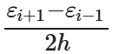. Dividing by small h can make small measurement errors dominate the derivative.
Smoothing (scipy.signal.savgol_filter) is often necessary for noisy data. However, it is a modelling decision, not a new measurement. Params like window_length and polyorder must be carefully selected, justified and, and tested for sensitivity. Overly aggressive smoothing can distort or flatten real features.

Engineering Judgement.
- Validate Data: Ensure coordinates are finite, strictly ordered, and free of duplicates.
- Visualize: Always plot the raw sampled quantity before differentiating.
- Choose Stencil: Select an appropriate stencil (forward, backward, centred, one-sided) based on data availability and position (interior vs. boundary).
- Use Actual Coordinates: Employ np.gradient(values, coordinates) to correctly account for spacing.
- Verify: If possible, validate the implementation against a known smooth function.
- Analyze Sensitivity: Study how results change with varying step sizes, boundary treatments, and noise levels.
- Report Comprehensively: Document all assumptions, units, chosen methods, smoothing parameters, and known limitations of the results
7.2 Ordinary Differential Equations and Initial Value Problems
ODE relates an unknown function to one or more of its derivatives with respect to a single independent variable
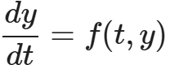
Terms:
- Independent Variable, t: The coordinate along which the state evolves (usually time)
- State y(t): the unknown function representing the systems state
- State Derivative dy/dt: The instantaneous rate of change of the state
- Right-hand side (RHS): f(t,y): A function that returns the derivative based on time and state. This defines the local slope of any valid solution.

2. The initial-Value problem (IVP)
An ode alone admits a family of solutions. An IVP combines the ode with a specific initial condition y(t_o) = y_0 to select a unique trajectory.

Heat Thermal Mass example.
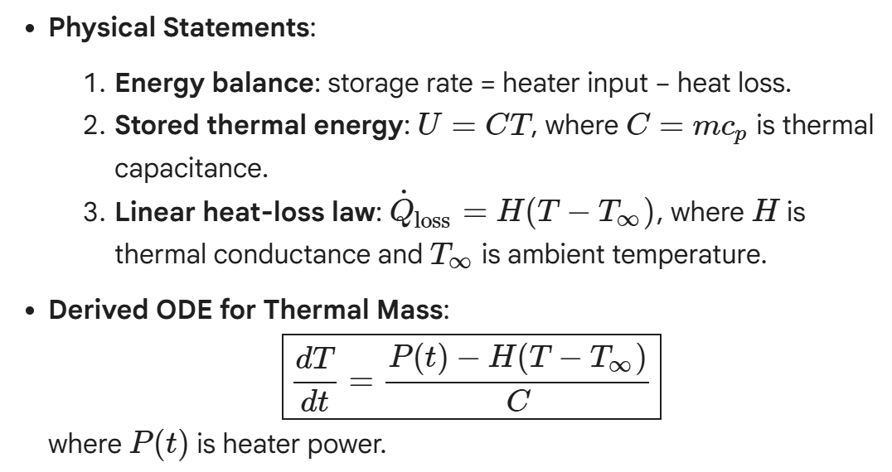

Equilibrium:
An equilibrium is a state where the derivative is zero. No instantaneous change

Thermal Equilibrium Equation (for constant P)
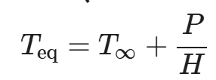
If T<Teq , the model predicts warming. If T>Teq , it predicts cooling.

Time Constant: characterises the speed of response for stable first-order models
Thermal Example
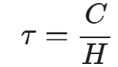
After one time constant, the system has completed 63.2% of its total change towards the equilibrium.

ODE and Integral Viewpoints

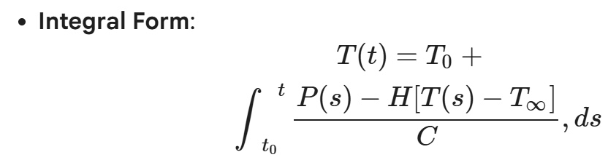
Requires simultaneous construction of state and accumulated change.

Classifying ODE models:
- Order: Determined by the highest derivative present
- Linear: State and its derivatives appear only to the first power and are not multiplied together (e.g., the thermal model).
- Nonlinear: Contains nonlinear state dependence (e.g., v|v| for quadratic drag).
- Autonomous: No explicit independent-variable dependence (e.g., constant-input thermal model).
- Non-autonomous: Time appears explicitly through an input or parameter (e.g., thermal model with P(t)).
- Scalar: Involves one state.
- System: Involves several coupled state derivatives.

Model Validation and Parameter Calibration
Types of discrepancies
- Measurement error
- Parameter error
- Model-form error
- Numerical error
Parameter Calibration: adjusting uncertain model params to minimise the difference between model prediction and experimental measurements. This often uses an objective function like least-squares.

Least-squares objective:
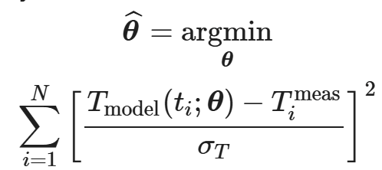

where θ=(C,H) are the parameters to be fitted.

Residuals: The power residual 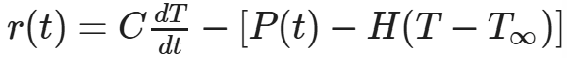 can help identify model mismatch, but its interpretation must consider noise and smoothing.

Key Takeaways
- The ODE's right-hand side provides a local rate, not a future state.
- An IVP requires the ODE and all initial conditions.
- A well-specified IVP contract includes all states, parameters, inputs, and initial conditions.
- Reducing numerical error doesn't fix incorrect physics or parameters; these must be addressed through careful model formulation and calibration against independent data.
7.3 Euler’s Method
Simplest explicit time-marching numerical method for approximating solutions to ODE’s. Crucial when analytical solutions are not available, providing a foundational understanding for more advanced ODE solvers.

Initial Value Problem
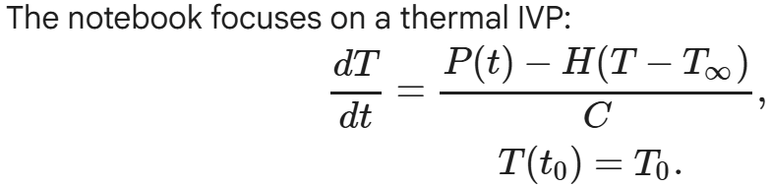
Eulers method approximates the future state of a system by evaluating the current derivative (slope), assuming that slope remains constant over a small finite time step, then advancing the state. At a known point, the ode supplies the local slope. The tangent-line approximation over a short interval is used to predict the next state.

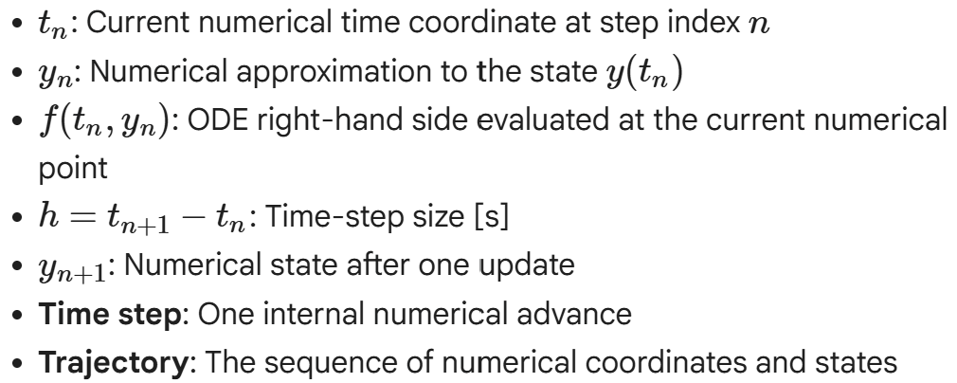
Explicit Euler update. For a first-order IVP:
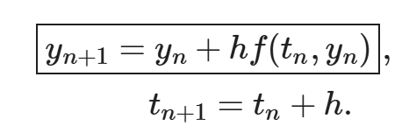
Method is explicit because all quantities on the right-hand side are known at step n

Step- by-step calculation
Each step re-evalutes the odes rhs. Avoiding indefinite extension of a single tangent.

Reusable solver
A general euler_scalar function is introduced, designed to:
- Accept the ODE right-hand-side function (rhs)
- Retain both time and state coordinates
- Avoid stepping beyond the requested final time
- Shorten the last step if the interval is not an exact multiple of h

Step Size, cost vs accuracy.
Lower h = more accurate = more computational costs.

Local and global truncation error
Local: error introduced by a single euler step, assuming it starts from the exact state. Comes from Taylor expansion of exact solution, Euler retains the first two terms
Global: accumulated error after many steps tf-t0/h steps. For a stable, smooth problem its O(h)

Because of the global error being O(h) it is a first-order method

Verifying First-Order Convergence
The global error E(h) is expected to behave as 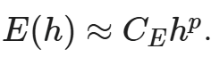the observed order of convergen (p_obs) between successive step sizes can be calculated as;
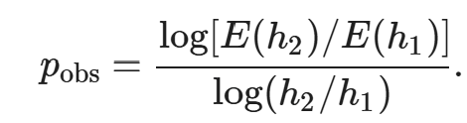
Should approach 1.

Stability
Ensures that errors do not grow indefinitely when the physical system’s true solution would decay. For a decay test equation 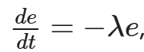, euler method yields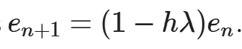.
The amplification factor: 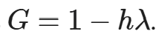
For errors to decay the |G| < 1 the condition 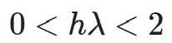 must be met.
Solution can be oscillatory or physically implausible if G < 0 or even |G| < 1
Discontinuous inputs
If inputs are discounted, the Euler method requires special handling. To maintain accuracy the integration should be segmented forcing a step endpoint exactly at the known switching time. This prevents the method from applying the old input for too long.

Internal solver steps (t_n^{\mathrm{step}}) are determined by numerical accuracy and stability requirements. Measurement times (t_i^{\mathrm{meas}}) are dictated by experimental design. These sets are generally different. Model predictions are interpolated (np.interp) at measurement times for residual calculation and comparison, rather than forcing solver steps to align with every measurement.

Using a coarse numerical method (large h) for parameter calibration can lead to biased results. The optimizer might adjust physical parameters (e.g., C and H) to compensate for numerical discretization error, rather than finding the true physical values. To avoid this, it's critical to:
- Establish numerical convergence before trusting fitted parameters.
- Ensure solver error is small compared to measurement uncertainty.
- Hold numerical settings fixed when comparing parameter candidates.
- Validate the fitted model on independent data without refitting.
Engineering checks/limitations
- Units: hf should have the same units as the state.
- Initial condition: The first numerical value must match the specified initial state.
- Direction: The first update should agree with the expected sign of the balance.
- Resolution: Important outputs should converge as
- h
- decreases.
- Stability: The step size must be within the relevant stability limit.
- Physical constraints: Positivity, bounds, and monotonic behavior should be preserved.
- Inputs and events: Discontinuities must be represented at step boundaries.
- Data comparison: Predictions and observations should be compared at common times.
- Calibration: Fitted parameters should be insensitive to further numerical refinement.

7.4 Runga-Kutta Method
Why one slope is insufficient:
Euler uses only the slope at the beginning of each step. When the rate changes significantly with teh interval, this single slope becomes a poor approx. RK method addresses this by evaluating the ODE at multiple intermediate steps and combining these slope estimates for a more accurate update.
- k_j: Stage-j derivative estimate (units of dy/dt).
- Trial state: Temporary state used to evaluate a later stage; not an accepted next state.
- Stage: One right-hand-side evaluation inside a time step.
- Stage weight: Coefficient used to combine stage derivatives.
- Order p: Global error decreases approximately as h^p
- Embedded pair: Two RK formulas of different order sharing stages to estimate local error.
- Adaptive step: Internally selected step size changed based on an error estimate.
Midpoint Runge-Kutta Method (RK2)
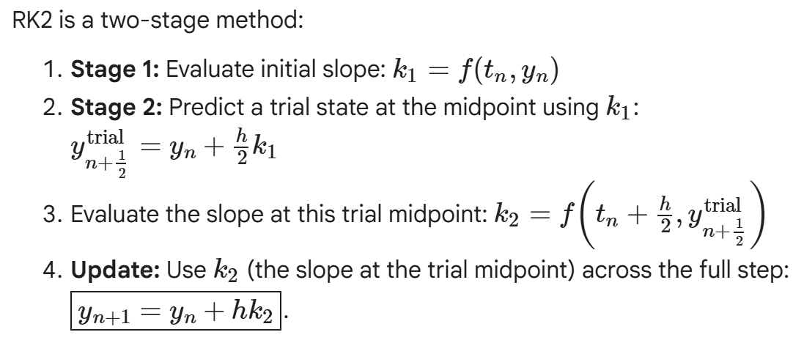
RK2 uses two right-hand-side evaluations per step and achieves second-order global accuracy O(h^2)

Fourth-Order Runge-Kutta Method (RK4):
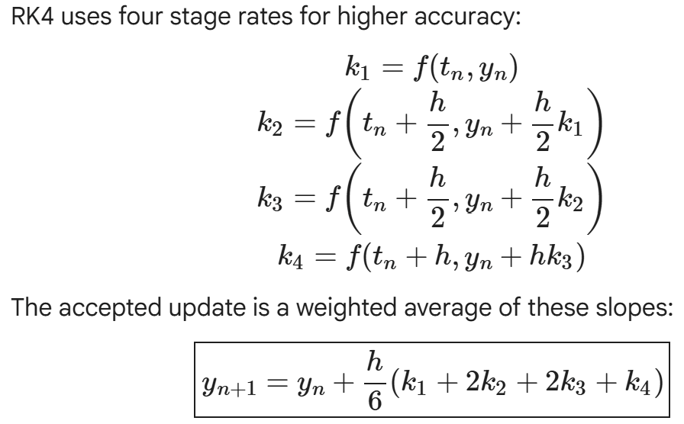
RK4 uses four right-hand-side evaluations per step and achieves fourth-order global accuracy O(h^4).
Why 2 midpoint stages?
Improves the final full-step slope combination.

Stability Functions
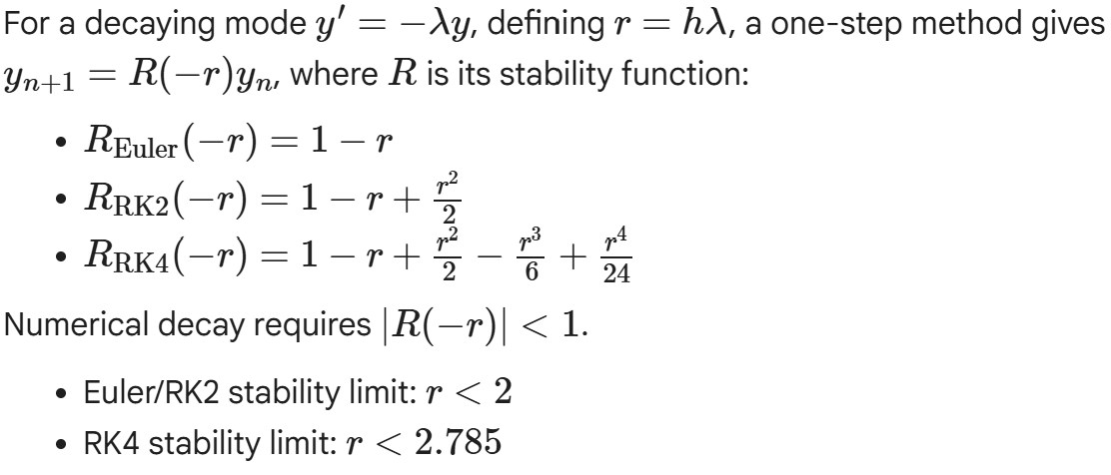
Look in notebook for how to apply runge kutta
- Define and Test: RHS, initial state, integration interval.
- Verify: Use a reference problem for stage implementation and order.
- Select Method: Fixed-step RK for controlled studies, adaptive RK for general use.
- Set Tolerances: Relative to state scales and engineering requirements.
- Align Segments: With discontinuities and events.
- Inspect Diagnostics: Termination status, accepted range, nfev, physical constraints.
- Refine: Steps or tolerances, check output convergence.
- Evaluate Predictions: At measurement coordinates before calculating residuals.
- Keep Error Small: Numerical error should be small relative to measurement and parameter uncertainty.

Higher-Order ODE
All you’d expect. Move on with your life

Competency Hurdle

Competency Hurdle
Life Long Learning

Chosen Topic: Is AI an appropriate tool for filling the knowledge gap present within the Aerospace & Defence Sector.

Reference 1: https://www.apm.org.uk/resources/ai-and-automation-in-the-aerospace-and-defence-sector/

AI is already being applied within the sector, however the rollout has been particularly cautious in comparison with other industries under the engineering bracket.
The Aerospace and defence industry faces substantial knowledge gaps, where high-level roles require professionals with 20-30 years of experience, and as these employees retire, the younger less experienced talent can be left without much guidance. With growing demand in the industry and 30% of industry workers being over 55, the sector is under immense pressure to ‘fill the gap’

(Further backed up by: https://www.mckinsey.com/industries/aerospace-and-defense/our-insights/the-talent-gap-the-value-at-stake-for-global-aerospace-and-defense)

Reasons for the gap
- Retiring employees. A large portion of the workforce is 55+ and these employees are transitioning to retirement. Without an efficient way for them to pass their skills down to new, younger employees, their skills are being lost.
- Staff retention. Younger staff tend to change jobs more quickly than previous generations, resulting in specific skill sets being lost/not retained
- Hybrid working. The lack of face to face interaction on a regular basis means that often key discussions/learning opportunities are missed and technical skills are only retained by specialised employees.

Limitations of AI, why they industry is cautious
- Data sharing/privacy concerns: Given a lot of the work done in defence particularly is on a ‘need to know’ basis, feeding this information into a publically available LLM raises serious data security concerns.
- Ethical Concerns (https://www.defence.gov.au/news-events/releases/2021-02-16/defence-releases-report-ethical-use-ai): The discussion referenced in this article produced a technical report with the following major points of discussion
- Managing the balance between being too slow to adopt (military disadvantage) and taking it on prematurely (inadvertent harms)
- Responsibility: who is responsible for output, an understanding of the AI model is necessary in this industry. Without understanding the relationship will break down. Education to military personnel/users is necessary. “Who is in command” and humans are set to bear responsibility. Frameworks need to be set around the accountability of decisions made with the assistance of AI.
- Trust: trust needed in the technical systems (getting the right output from inputs) and trust in the people/organisations that develop/deploy them.
- Governance: How is ai controlled. Requires a convoluted and rigorous system of control to be defined, takes time and is ever changing as the technology evolves.
- Law: what legal frameworks are required to lawfully apply AI
- Traceability: How are the actions of AI recorded, need to be able to trace, document and understand the different decisions that were made along the way.

Week9

Prework
9.1 Stability of Ordinary Differential Equations
Numerical Stability (Linear algebra): How a calc differs from the true solution due to instabilities which are caused by proximity to singularities of various kinds. The solution of an ill-conditioned matrix, for example, may become numerically unstable.

Numerical Stability (Differential Equation): How errors propagate through an algorithm and affect the result. A code is numerically unstable when errors, e.g rounding errors cause a large deviation of the final answer from the exact solution.

- Stable if errors remain bounded

Forward error: the difference between the computed solution and the true solution

Backward error: the smallest perturbation to the input that makes the computed solution exact for a nearby problem

Forward stable: when the relative forward error is of the order of the product of the condition number and the machine precision, u:
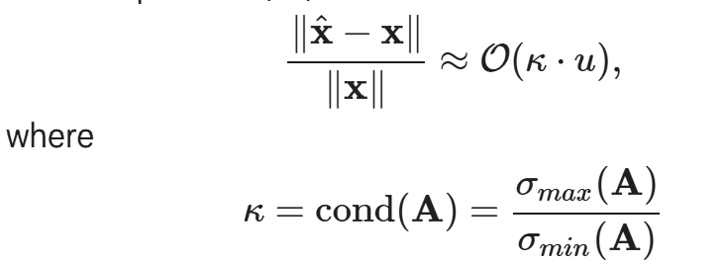
Backward stable: when the relative backward error is of the order of machine precision, u:
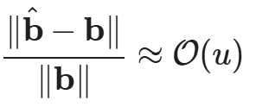
Backwards stable ⇒ forward stable, but the converse is not true.

Methods for solving a differential equation are said to be stable if they produce a bounded solution which imitates the exact solution. If the solution explodes, or diverges from the exact solution, it is unstable.
Absolutely or unconditionally stable refers to a method that is stable for all values of the parameters, e.g. for all step sizes.

Conditionally stable refers to a method that is stable for some, but not all values of the parameters, e.g. stable for a finite range of step sizes.

Accumulated truncation error:

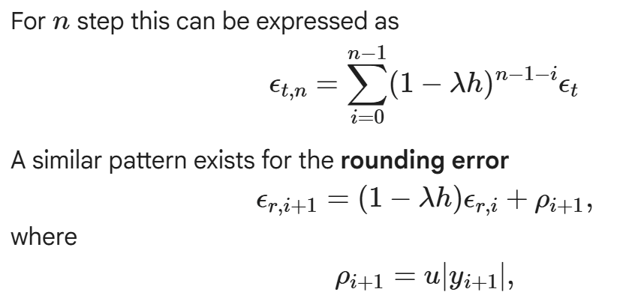
Euler method
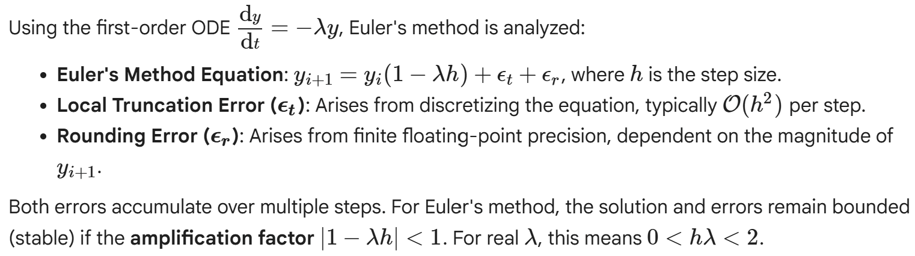

Selecting optimal step size:
Smaller step size → lower truncation error, however with more steps a great accumulation of rounding errors can occur.
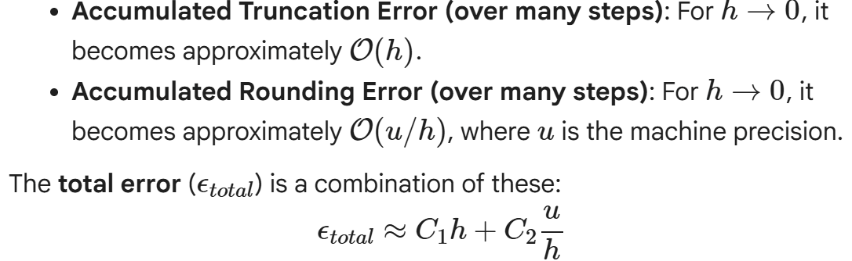
Therefore an optimal step size is revealed 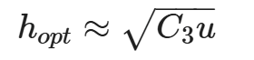

Perturbation Theory:
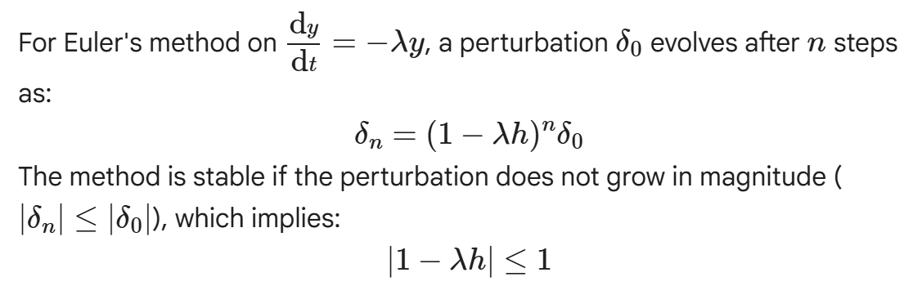
This condition defines the region of stability in the complex plane, typically a unit circle centered at (1,0) where 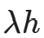 must reside

9.2 Stiff ODE’s
Stiff ODE’s are characterised by solutions containing widely differing time scales
- Necessitates extremely small numerical step sizes for stability, much smaller than accuracy alone requires

Challenge arises when components of an ODE evolve at different rates.

Example stiff ODE:
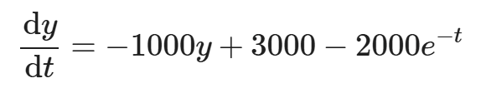

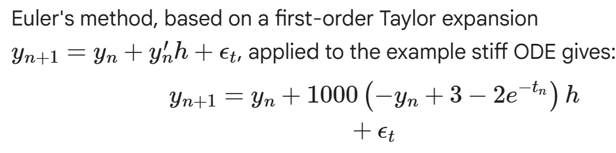
The perturbation method yields
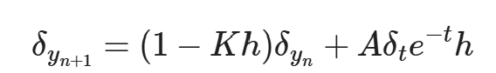

Moving stability condition: stability depends on current value of y_n
System can be unconditionally unstable initially, for a small value of y_0, meaning any positive step size h will lead to error growth. Growth is limited with small h.

Implicit Methods for Solving ODE’s
Explicit methods: calculate the state of a system at a later time, y_n+1, purely from the state of the system at the current time, y_n.
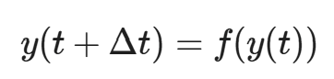
Implicit methods: Calculate the state of a system at a later time y_n+1 from the state of the system at both the current time (y_n) and the updated, later time (y_n+1)
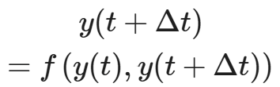

Forward Euler = explicit 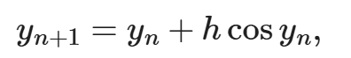
Backward euler = implicit 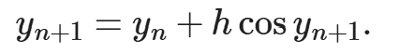
Stability of the backward euler
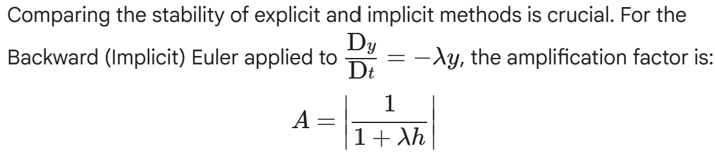
- Backward is unconditionally stable for linear odes. (advantage over forward which have stability limits)
- Large h = large truncation error

Non-linear ode’s

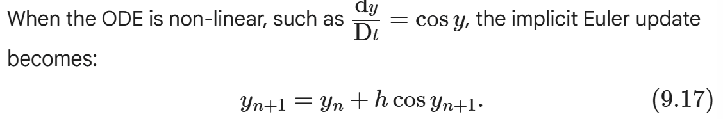
- Must be solved iteratively by finding the root of the equation: 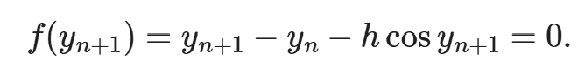
Newton-Raphson Method:
Iterative root-finding method. Refines an initial guess for the root using the functions value and its derivative
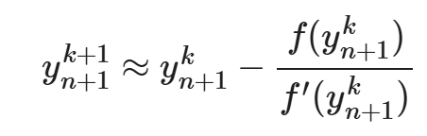
Semi-Implicit method - Newton-style linearisation

Used to avoid the iterative costs of Newton's method.
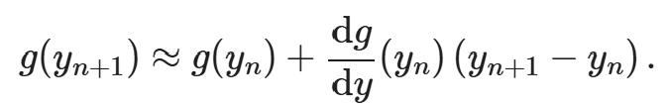
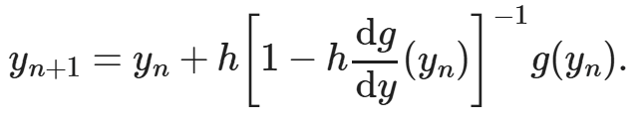

9.4 Boundary Value Problems
The shooting method:
Transforming BVP into IVP by ‘guessing’ the unknown initial conditions.

Apply Newton's method for root-finding to find the roots of the shooting function 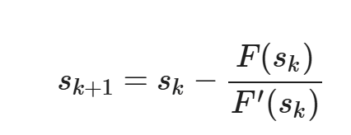
Sensitivity variables:
